
SBCCD
Starfish Systems Settings Manual

Last Updated:
June 2023




Table of Contents

HISTORY 5

SYSTEM SETTINGS 7
Session Settings 7
System Announcements 7
Terms 7
Silent Mode 7
SMTP Configuration 7

INTEGRATIONS 9
Schedule Imports 9
Import Status 9
LMS Courses 9

USERS AND ROLES 10
Batch Assign Roles 10
Batch Files 10
Cohorts (cap of 50) 10
Cohort Types 11
Roles 12
Role Mapping 30
Users 30

DATA AND ANALYTICS 31
Attributes 31
Organizations 33
Attributes vs. Organizations vs. Cohorts Comparison Chart 36

FEATURE CONFIGURATION 37
Appointment Types 37
Custom Intake Questions 38
Degree Planner 39
Flag Thresholds 39
Kiosks 39
Note Types 39
Progress Surveys 40
Raise Your Hand 46
Services 46
Speed Notes 46
Student Intake 47
Student Intake Intervention Matrix 51
Project Hope Intake Form 53
Success Plan Types 56
Tracking Rules 56
FLAGS 56
KUDOS 59
REFERRALS 61
To Dos 63
Student Success Plans To-Do Items 64
CLOSURE REASON SETTINGS 68

MESSAGING TEMPLATES 69
Settingstem 69
Snippets 69
Advanced Fields 70
Templates (SBCCD) 71

REPORTS 80
Activity 80
Assignment Analysis 80
Degree Planner 80
Early Alert Summary 80
Instructor Inactivity 80
Intervention Analysis 80
Low Grades 80
Meetings 80
Notes 80
Relationships 80
Required Appointment 80
Services 81
Starfish Configuration 81
Student Intake 81
Success Plan 81
Surveys 81
Tracking Items (Flags, Kudos, Referrals, and To-Dos) 81

Semesterly/Annual System Updates Check List 82
Campus Specific Starfish Support 82
Starfish Work Group 83
DCS Tech Team 84

PRODUCT ENHANCEMENT REQUESTS 86

Appendix 89
New Starfish Role Request 90
New Starfish Cohort Request 91
New Starfish Attribute Request 91
In-Class Reminder of Starfish Tracking Items 93
Starfish Workflow 95
Quick Reference Guide for Tracking Items 96
Flag Triage Action Guide for Gen. Pop. Students 97

HISTORY

Initially, Crafton Hills College was not in the market for a new Early Alert tool. There was a state pilot program for eight community colleges to adopt a degree planner software through Hobsons. We were selected for this pilot and joined with this intent. During the planning and setup process, Hobsons acquired Starfish Early Alert, and the two products merged. This turned out to be an unforeseen benefit to the college.

We worked as a team with members from both colleges to initially build the system. This required much communication with constituency groups (Faculty, Staff, Management, and both Senates on both campuses) and report back to the team. Collaboration, communication and feedback centered around enabled features, wording of messaging templates, and workflow. We began building the system with the vendor (and an outside data entry service) in January of 2016, piloted the software with a small group of volunteer faculty in spring 2017, and rolled out to the entire campus in fall 2017.

During our campus pilot in spring of 2017, as well as the full campus rollout during the 2017-2018 academic year, our team talked about Starfish whenever and wherever we could: flex days, in service, committee meetings, etc. We purchased and distributed promotional items such as pens, pins, mugs, and notepads, as well as hung Starfish flags around campus and decorated walkways with Starfish signage.
Once the system hit its full implementation stage, the project at Crafton Hills College began to be overseen primarily by one Faculty member and various “Flag Triage” folks, with continued support and supervision of our two Deans of Student Services.

The primary faculty member on the project holds the title: “Faculty Lead of Starfish Support” and is provided with .25 reassign time to devote to the project. Her duties include:
- providing on-going trainings to campus members in a variety of forms (demos, workshops, open labs, one-on-ones, department meetings, video tutorials, and informational emails)
- answers any questions and troubleshooting issues as they arise
- acts as the liaison between the campus/district and the vendor for help tickets, updates, and other communication needs
- campus marketing and ongoing engagement in the system (posters, fliers, awards, incentives, promotional items, etc.)
- general system maintenance and up keep (settings, services, tracking items, cohorts, and more)
- updating the campus Starfish Settings Manual
- working with the Office of Research and Planning to collect and analyze data
- keeping the campus updated on project information through campus Starfish website as well as monthly newsletters and biweekly emails

The Flag Triage Folks, made up of Counselors, Student Success Advisors, and other Staff, monitor the tracking items as they come in, make student contact, connect students to campus resources, and provide follow up and closure. They share the load of working with all populations of students including general population, EOPS, CARE, CalWORKs, Guardian Scholars, DSPS, Veterans, and more.

Our campus recognized early on, that without Faculty inputting tracking items into Starfish, the system would be pointless. However, without the Student Services side of the house addressing these tracking items and closing the loops, faculty would not feel inclined to continue its use. It has truly been a uniting project, joining together both Instruction and Student Services. An example of our collaboration included moving our campus’s EOPS paper progress surveys into Starfish. This quickly helped broaden faculty adoption of the software as well as streamlined processes, but not without growing pains. Having a strong implementation team at Crafton was, and still is, essential in our success and efficiency in building the system and its current and ongoing success.

Currently, anyone who is new to the system receives direct training and guidance from the Faculty Lead of Starfish Support. We also have online resources available to those who prefer a more independent approach to learning the system.

SYSTEM SETTINGS

Session Settings
Set the value for the user's session timeout in minutes. For security reasons, the maximum time that can be set is 120 minutes.
SBCCD Session Times out after 120 minutes.

System Announcements
This is the <b>PRODUCTION</b> tenant.

Terms
All role relationships in Starfish are term-based. Starfish automatically assigns roles based on enrollments in courses and groups or organizations, and the term for these roles is determined by the designation for the term in the course or group/organization ID. Add all of your terms here. The term code for each term must be specified. This is the ID that is used to refer to the term in course IDs (e.g., FA2012 would be the term code for the course FA2012.MATH110.08).
Some relationships, such as those between advisors and advisees, are not term-based. Often, an advising relationship is considered ongoing until a point in time (e.g., the student declares a major, reaches a certain number of Credit Hours, enrolls in a program).
You might consider assigning relationships such as these to the built-in "Ongoing" term, rather than one term at a time. The Ongoing term has no end date, so you will only need to assign relationships to this term once. You cannot edit the start and end dates of the Ongoing Term.
All terms prior to five years of the current term, should be marked “false” in the “Display in Menu” field. Terms within five years prior and three years in the future of the current term, along with the term “Ongoing,” should be marked as “true.”

Silent Mode
Silent Mode is a testing tool and should only be enabled during your test phase. It is intended to only be enabled prior to launching the system to your end users. This mode prevents emails from being sent to users in the system who are not involved in the testing process and should only be enabled under the advisement of your Implementation Manager.
Silent Mode requires specification of email addresses that should receive emails from the system for scheduled appointments, raised tracking items, and other actions in the system. Additionally, a trap email address should be specified to receive all emails that would normally be sent to addresses not on the whitelist.
Trap email account: edplan-test@sbccd.cc.ca.us. Whitelist Email Address field should be left blank since this feature is only used when in test mode.

SMTP Configuration
In order for Starfish emails to be delivered on your institutions’ behalf, you must configure SMTP related settings so that Starfish is trusted by your Domain Name Service (DNS). You will use the option below to generate the values your IT team will need to configure SMTP for your institution to trust Starfish.
We use Amazon’s Simple Email Service (SES) for our SMTP service. Links to Amazon’s documentation regarding these settings as well as details and instructions for setting each of these options in Starfish can be found in Starfish help for tenant admins on the page titled Configure SMTP Settings and DNS Records to Trust Starfish Emails

Domain Name: sbccd.cc.ca.us. Current Status is Success.

INTEGRATIONS

Schedule Imports
Use this to customize the times that your system will send Starfish data. Note that these settings only determine when data is sent to Starfish, not when the data will be available in Starfish. Data sent to Starfish will be put in a queue for processing, and it may take up to several hours to process the data depending on the time of day and number of data packages ahead of yours in the queue.

Scheduled Imports are as follows:
Canvas- Start time 3:45am, Interval Daily.
Exporter- Start time 10:17pm, Interval Daily.
SFTP- Start time 1:45am, Interval Daily.
SIS- Start time 2:45am, Interval Daily.

Import Status
View imports to this Starfish tenant in the list on this page. When data is pushed to Starfish, it is queued up and processed in order after the imports ahead of it. Data imports also do not run during our peak usage hours of 8am EST to 5pm EST. If you have pushed data to Starfish but do not see the import here, it is likely still in the import queue. Check back later to view the details. If you need data to run immediately during our peak hours, contact Starfish Technical Support. We can allow data pushes to import during peak hours if necessary.
The Import ID indicates the date and time that the data was pushed from the LMS, SIS or Exchange server. If the import ID is suffixed with ".repack", this means that Starfish staff had to repack and rerun the import to resolve an error that occurred during the import process.
The Source column indicates where the data comes from, and the Status column indicates whether or not the import was successful. If an import status is "FAILED," the import was a complete failure, meaning no data was imported. If the import status is "COMPLETED," the import was processed. Even in a successfully completed import, some data may not have been imported due to data errors. In this case or the case of a failure, viewing the logs should provide you with more details about the cause of the errors.

LMS Courses
Course and enrollment data are retrieved primarily from the SIS. However, some course data such as grade and activity in the online course must be retrieved from the Learning Management System. Specify the courses for which this data must be retrieved. Note that selecting all courses will place greater performance demand on your system, so you should only select courses for which this data is needed in Starfish and cannot be retrieved from the SIS
SBCCD does not have any courses listed here.

USERS AND ROLES

Batch Assign Roles
Browse and select a file containing role assignments for users in the system. All role assignments are term specific, so users who are assigned a role will only have the privileges associated with that role for the selected term. Select the delimiter used in the file to separate columns of data.
View detailed information about the data format for the batch file.
Note: The default mode is to create new relationships for the selected group and term. If you select 'Overwrite' then ALL existing relationships for the given group and term will be completely removed and replaced with those in the file you are currently uploading.

Batch Files
Nothing listed here.

Cohorts (cap of 50)
Complete list of SBCCD Cohorts include:
Cohort Name | Cohort Type | Criteria
Crafton Athletes (CATHL) | Crafton Hills College | Org Membership: CATHL
Crafton Calif Adult Education Pgm (CCAEP) | Crafton Hills College | Org Membership: CCAEP
Crafton CalWORKs (CCALW) | Crafton Hills College | Org Membership: CCALW
Crafton DSPS Students (CDSPS) | DSPS | Org Membership: CDSPS
Crafton EOPS Combined (CEOPC) | Crafton Hills College | Org Membership: CEOPC
Crafton EOPS/CARE (CEOPS) | Crafton Hills College | Org Membership: CEOPS
Crafton Financial Aid Student | Crafton Hills College | Org Membership: CSTDS; Attribute: Financial Aid Status - Specific Value = True
Crafton Foster Youth (CFOSY) | Foster Youth/Guardian Scholars | Org Membership: CFOSY
Crafton Honors (CHNRS) | Crafton Hills College | Org Membership: CHNRS
Crafton International (CINTL) | Crafton Hills College | Org Membership: CINTL
Crafton On Probation Students | On Probation | Org Membership: CSTDS; Attribute: On Probation - Assigned to Student
Crafton Promise (CFCPP) | Crafton Hills College | Org Membership: CFCPP
Crafton Self-Reported Vets/Dependents (CSVET) | Crafton Hills College | Org Membership: CSVET
Crafton STEM (CSTEM) | Crafton Hills College | Org Membership: CSTEM
Crafton Students | Crafton Hills College | Org Membership: CSTDS
Crafton Veterans (CVETS) | Crafton Hills College | Org Membership: CVETS
Valley Athletes (VATHL) | San Bernardino Valley College | Org Membership: VATHL
Valley Bound ** | San Bernardino Valley College | Section Enrollment (Term Specific)
Valley Calif Adult Education Pgm (VCAEP) | San Bernardino Valley College | Org Membership: VCAEP
Valley CalWORKs (VCALW) | San Bernardino Valley College | Org Membership: VCALW
Valley CCAP (VCCAP) | San Bernardino Valley College | Org Membership: VCCAP
Valley Dreamers and Guardian Scholars ** | San Bernardino Valley College | Section Enrollment (Term Specific)
Valley DSPS Students (VDSPS) | DSPS | Org Membership: VDSPS
Valley DUAL (VDUAL) | San Bernardino Valley College | Org Membership: VDUAL
Valley EOPS/CARE (VEOPS) | San Bernardino Valley College | Org Membership: VEOPS
Valley Financial Aid Students | San Bernardino Valley College | Org Membership: VSTDS; Attribute: Financial Aid Status - Specific Value = True
Valley First Year Experience (FYE) ** | San Bernardino Valley College | Section Enrollment (Term Specific)
Valley Foster Youth (VFOSY) | Foster Youth/Guardian Scholars | Org Membership: VFOSY
Valley Honors (VHNRS) | San Bernardino Valley College | Org Membership: VHNRS
Valley International (VINTL) | San Bernardino Valley College | Org Membership: VINTL
Valley MESA (VMESA) | San Bernardino Valley College | Org Membership: VMESA
Valley Middle College (VMCHS) | San Bernardino Valley College | Org Membership: VMCHS
Valley Promise (VFCPP) | San Bernardino Valley College | Org Membership: VFCPP
Valley STEM (VSTEM) | San Bernardino Valley College | Org Membership: VSTEM
Valley Students | San Bernardino Valley College | Org Membership: VSTDS
Valley GenGo (VGNGO) | San Bernardino Valley College | Org Membership: VGNGO
Valley On Probation Students | On Probation | Org Membership: VSTDS; Attribute: On Probation - Assigned to Student
Valley Self-Reported Vets/Dependents (VSVET) | San Bernardino Valley College | Org Membership: VSVET
Valley Veterans (VVETS) | San Bernardino Valley College | Org Membership: VVETS
** Cohorts need to be updated each term. These cohorts are based on course/section enrollment and the term needs to be updated (Fall = V-SDEV-102 and Spring = V-SDEV-103). Double check section numbers with MariCarmen Rodriguez and Saraf Williams.
Valley Dreamers and Guardian Scholars (Fall): V-SDEV-102-14-2018FA (Spring): V-SDEV-103-13-2019SP
Valley FYE (Fall): V-SDEV-102-93-2018FA, V-SDEV-102-94-2018FA (Spring): V-SDEV-103-94-2019SP, V-SDEV-103-93-2019SP

Cohort Types
- Crafton Hills College (Category: Campus/Location)
- DSPS (Category: Special Population)
- Foster Youth/Guardian Scholars
- On Probation (Category: Special Population)
- San Bernardino Valley College (Category: Campus/Location)

Roles
Do NOT change any role titles without informing district tech team.
Active Roles for SBCCD system:

- Adult Education Program Support Staff (XfunctionalLeader)
- Athletic Coach (XfunctionalProvider)
- Athletic Counselor (XfunctionalLeader)
- Athletic Director I (XfunctionalLeader)
- Athletic Director II (XfunctionalLeader)
- Basic Needs Coordinator (XfunctionalLeader)
- Basic User (BasicUser)
- CalWORKs Counselor (XfunctionalLeader)
- Calendar Manager (CalendarManager)
- Campus Leadership (XfunctionalLeader)
- DP Testor (XfunctionalProvider)
- DSP&S Counselor (XfunctionalLeader)
- DSP&S Support Staff (XfunctionalLeader)
- EOPS Counselor (XfunctionalLeader)
- EOPS Support Staff (XfunctionalLeader)
- Evaluator (XfunctionalLeader)
- Financial Aid Support (XfunctionalLeader)
- First Yr. Experience Counselor (XfunctionalLeader)
- Flag Triage (XfunctionalLeader)
- Foster Youth Counselor (XfunctionalLeader)
- General Counselor (XfunctionalLeader)
- Guardian Scholars Counselor (XfunctionalLeader)
- Health and Wellness
- Honors Coordinator (AcademicLeader)
- Honors Counselor (XfunctionalLeader)
- Self-Reported Veterans Support Staff (XfunctionalLeader)
- Instructional Support Staff (PeerServiceProvider)
- Instructor (Instructor)
- International Std Counselor (XfunctionalLeader)
- Middle College Counselor
- Outreach Support Staff (XfunctionalLeader)
- Puente Counselor (XfunctionalLeader)
- Researcher (XfunctionalLeader)
- SBCCD Tech Team (XfunctionalLeader)
- Self-Reported Veterans Support Staff (XfunctionalLeader)
- STEM Counselor (XfunctionalLeader)
- Std. Student Services Div. Supp. Staff (XfunctionalLeader)
- Student (Student)
- Student Calendar Manager (StudentCalendarManager)
- Student Support Staff (XfunctionalLeader)
- TA (TA)
- Tenant Admin (TenantAdmin)
- Tutoring Center Coordinator (AcademicLeader)
- Valley Bound Commit Counselor (XfunctionalLeader)
- Veterans Counselor (XfunctionalLeader)
- Veterans Support Staff (XfunctionalLeader)

On the next page, you will find Role Visibility and Access to Student Information organized by role type. The table below shows selection and mapping criteria for each role, as outlined on the XEPIOG screen in Colleague.
Starfish Role | ID | Selection Statement | Populate in Starfish | Child Role | Child Type | Term
Adult Education Program Support Staff | AESTF | SELECT STAFF  WITH S02.STAFF.STARFISH.ROLES = 'ADEDSPTSTF' | N | Student | ASTDS | Ongoing
Athletic Coach | ATHCH | SELECT STAFF  WITH S02.STAFF.STARFISH.ROLES = 'ATHCOACH' | N | Student | _ATHL | Ongoing
Athletic Director I | ATHD1 | SELECT STAFF  WITH S02.STAFF.STARFISH.ROLES = 'ATHDIR-I' | N | Student | _ATHL | Ongoing
Athletic Director II | ATHD2 | SELECT STAFF  WITH S02.STAFF.STARFISH.ROLES = 'ATHDIR-II' | N | Student | _ATHL | Ongoing
CHC BIT | CBIT | SELECT STAFF  WITH S02.STAFF.STARFISH.ROLES = 'CHCBIT' | N | Student | ASTDS | Ongoing
Basic Needs Coordinator | CBNCR | SELECT STAFF  WITH S02.STAFF.STARFISH.ROLES = 'CBNCOORD' | N | Student | ASTDS | Ongoing
CHC Health & Wellness Support Staff | CHWSS | SELECT STAFF  WITH S02.STAFF.STARFISH.ROLES = 'CHCHWSS' | N | Student | ASTDS | Ongoing
Campus Leadership | CMPLD | SELECT STAFF  WITH S02.STAFF.STARFISH.ROLES = 'CAMPUSLEAD' | N | Student | ASTDS | Ongoing
CalWORKs Counselor | CWRKC | SELECT STAFF  WITH S02.STAFF.STARFISH.ROLES = 'CALWKCOUN' | N | Student | _CALW | Ongoing
DSP&S Counselor | DSPSC | SELECT STAFF  WITH S02.STAFF.STARFISH.ROLES = 'DSPSCOUNS' | N | Student | _DSPS | Ongoing
DSP&S Support Staff | DSPSS | SELECT STAFF  WITH S02.STAFF.STARFISH.ROLES = 'DSPSSTAFF' | N | Student | _DSPS | Ongoing
EOPS Counselor | EOPSC | SELECT STAFF  WITH S02.STAFF.STARFISH.ROLES = 'EOPSCOUNS' | N | Student | _EOPS | Ongoing
EOPS Support Staff | EOPSS | SELECT STAFF  WITH S02.STAFF.STARFISH.ROLES = 'EOPSSPSTF' | N | Student | _EOPC | Ongoing
Evaluator | EVAL | SELECT STAFF  WITH S02.STAFF.STARFISH.ROLES = 'EVALUATOR' | N | Student | allStudents | Ongoing
Financial Aid Support | FINSP | SELECT STAFF  WITH S02.STAFF.STARFISH.ROLES = 'FINAIDSPRT' | N | Student | allStudents | Ongoing
Foster Youth Counselor | FOYOC | SELECT STAFF  WITH S02.STAFF.STARFISH.ROLES = 'FYTHCOUNS' | N | Student | _FOSY | Ongoing
First Yr Experience Counselor | FYREC | SELECT STAFF  WITH S02.STAFF.STARFISH.ROLES = 'FYECOUNS' | N | Student | _STDS | Ongoing
Guardian Scholars Counselor | GSCHC | SELECT STAFF  WITH S02.STAFF.STARFISH.ROLES = 'GSCHCOUNS' | N | Student | _STDS | Ongoing
Honors Counselor | HONCN | SELECT STAFF  WITH S02.STAFF.STARFISH.ROLES = 'HONRSCOUNS' | N | Student | _HNRS | Ongoing
Honors Coordinator | HONCR | SELECT STAFF  WITH S02.STAFF.STARFISH.ROLES = 'HONRSCOORD' | N | Student | _HNRS | Ongoing
Instructional Support Staff | INSTS | SELECT STAFF  WITH S02.STAFF.STARFISH.ROLES = 'INSTRSTAFF' | N | Student | _STDS | Ongoing
International Std Counselor | INTLC | SELECT STAFF  WITH S02.STAFF.STARFISH.ROLES = 'INTERNATNL' | N | student | _INTL | Ongoing
Intake Survey Manager | ISMGR | SELECT STAFF  WITH S02.STAFF.STARFISH.ROLES = 'INTSRVMGR' | N | Student | ASTDS | Ongoing
Middle College Counselor | MCCNS | SELECT STAFF  WITH S02.STAFF.STARFISH.ROLES = 'MIDCLCOUNS' | N | Student | _MCHS | Ongoing
Outreach Support Staff | ORSTF | SELECT STAFF  WITH S02.STAFF.STARFISH.ROLES = 'OUTRCHSPST' | N | Student | NSTDS | Ongoing
Puente Counselor | PUENC | SELECT STAFF  WITH S02.STAFF.STARFISH.ROLES = 'PUENTCOUNS' | N | Student | _STDS | Ongoing
Researcher | RSCHR | SELECT STAFF  WITH S02.STAFF.STARFISH.ROLES = 'RESEARCHER' | Y | Student | ASTDS | Ongoing
Athletic Counselor | SATHC | SELECT STAFF  WITH S02.STAFF.STARFISH.ROLES = 'ATHCOUNS' | N | Student | _ATHL | Ongoing
Valley Bound Commit Counselor | SBNDC | SELECT STAFF  WITH S02.STAFF.STARFISH.ROLES = 'VBOUNDCOUN' | N | student | _STDS | Ongoing
General Counselor | SFCNS | SELECT STAFF  WITH S02.STAFF.STARFISH.ROLES = 'GENCOUNS' | N | Student | allStudents | Ongoing
Flag Triage | SFLAG | SELECT STAFF  WITH S02.STAFF.STARFISH.ROLES = 'FLAGTRIAGE' | N | Student | _STDS | Ongoing
STEM Counselor | STEMC | SELECT STAFF  WITH S02.STAFF.STARFISH.ROLES = 'STEMCOUNS' | N | Student | _STEM | Ongoing
Student Success Support | STSUC | SELECT STAFF  WITH S02.STAFF.STARFISH.ROLES = 'STUSUCSTAF' | N | Student | ASTDS | Ongoing
Std Services Div Supp Staff | STSVS | SELECT STAFF  WITH S02.STAFF.STARFISH.ROLES = 'STUSERSTAF' | N | Student | allStudents | Ongoing
SBCCD Tech Team | TECHT | SELECT STAFF  WITH S02.STAFF.STARFISH.ROLES = 'SBTECHTEAM' | N | Student | allStudents | Ongoing
Tutoring Center Coordinator | TUTCC | SELECT STAFF  WITH S02.STAFF.STARFISH.ROLES = 'TUTCNTCORD' | N | Student | ASTDS | Ongoing
Veteran Support Staff Self Rptd | VETS2 | SELECT STAFF  WITH S02.STAFF.STARFISH.ROLES = 'VETSPTSTFR' | N | Student | _SVET | Ongoing
Veterans Counselor | VETSC | SELECT STAFF  WITH S02.STAFF.STARFISH.ROLES = 'VETCOUNSEL' | N | Student | _VETS | Ongoing
Veterans Support Staff | VETSS | SELECT STAFF  WITH S02.STAFF.STARFISH.ROLES = 'VETSPTSTF' | N | Student | _VETS | Ongoing

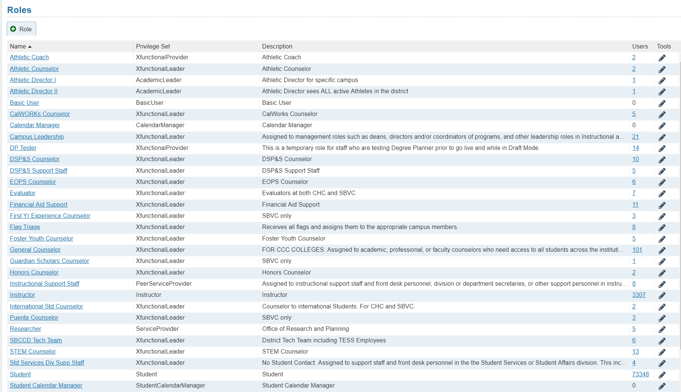
Directions: Please write the name of the role at the top and check all boxes you feel should be made available to the students as well as to the person(s) in that role.

- Name of role: Athletic Coach

- Privilege Set: XfunctionalProvider

- Visibility to students (keep in mind, only information entered into the person’s profile will be displayed):
- Show in Student Folder (Will be shown to other users. Confidential relationships should not check this box)
- Show in Student Success Network (student will see this person in their success network)
- Show Primary Phone Number to Student
- Show Cell Phone Number to Student
- Show Video Phone Number to Student

- Visible Student Data (to the person who is in this role):
- Academic Plans
- Admissions (high school GPA, first term date, ACT/SAT/TOEFL/placement scores)
- All Courses
- All Grades
- Courses for Course Context
- Demographics (date of birth, Pell Grant Eligible, First Gen Student status, Gender, Race, Residence)
- Email Addresses
- Grades for Course Context
- Phone Numbers
- Programs (major)
- Score Details
- Student Attributes (financial aid info, academic probation status, current GPA, etc.)
- Student Files
- Student ID
- Student Success Score
- Term Status (broken down by semester, FT vs PT, course load and unit count, academic standing, GPA)

Other Notes:
Directions: Please write the name of the role at the top and check all boxes you feel should be made available to the students as well as to the person(s) in that role.

- Name of role: Athletic Directors I & II

- Privilege Set: AcademicLeader

- Visibility to students (keep in mind, only information entered into the person’s profile will be displayed):
- Show in Student Folder (Will be shown to other users. Confidential relationships should not check this box)
- Show in Student Success Network (student will see this person in their success network)
- Show Primary Phone Number to Student
- Show Cell Phone Number to Student
- Show Video Phone Number to Student

- Visible Student Data (to the person who is in this role):
- Academic Plans
- Admissions (high school GPA, first term date, ACT/SAT/TOEFL/placement scores)
- All Courses
- All Grades
- Courses for Course Context
- Demographics (date of birth, Pell Grant Eligible, First Gen Student status, Gender, Race, Residence)
- Email Addresses
- Grades for Course Context
- Phone Numbers
- Programs (major)
- Score Details
- Student Attributes (financial aid info, academic probation status, current GPA, etc.)
- Student Files
- Student ID
- Student Success Score
- Term Status (broken down by semester, FT vs PT, course load and unit count, academic standing, GPA)

Other Notes: The Athletic Director I is the Athletic Director for specific campus. The Athletic Director I is the Athletic Director sees ALL active Athletes in the district.

Directions: Please write the name of the role at the top and check all boxes you feel should be made available to the students as well as to the person(s) in that role.

Name of role: Basic Needs Coordinator

Privilege Set: XfunctionalProvider

Visibility to students (keep in mind, only information entered into the person’s profile will be displayed):
- Show in Student Folder (Will be shown to other users. Confidential relationships should not check this box)
- Show in Student Success Network (student will see this person in their success network)
- Show Primary Phone Number to Student
- Show Cell Phone Number to Student
- Show Video Phone Number to Student

Visible Student Data (to the person who is in this role):
- Academic Plans
- Admissions (high school GPA, first term date, ACT/SAT/TOEFL/placement scores)
- All Courses
- All Grades
- Courses for Course Context
- Demographics (date of birth, Pell Grant Eligible, First Gen Student status, Gender, Race, Residence)
- Email Addresses
- Grades for Course Context
- Phone Numbers
- Programs (major)
- Score Details
- Student Attributes (financial aid info, academic probation status, current GPA, etc.)
- Student Files
- Student ID
- Student Success Score
- Term Status (broken down by semester, FT vs PT, course load and unit count, academic standing, GPA)

Other Notes: Role should have an ASTDS relationship
Directions: Please write the name of the role at the top and check all boxes you feel should be made available to the students as well as to the person(s) in that role.

- Name of role: Campus Leadership (all managers, directors, and coordinators)

- Privilege Set: XfunctionalLeader

- Visibility to students (keep in mind, only information entered into the person’s profile will be displayed):
- Show in Student Folder (Will be shown to other users. Confidential relationships should not check this box)
- Show in Student Success Network (student will see this person in their success network)
- Show Primary Phone Number to Student
- Show Cell Phone Number to Student
- Show Video Phone Number to Student

- Visible Student Data (to the person who is in this role):
- Academic Plans
- Admissions (high school GPA, first term date, ACT/SAT/TOEFL/placement scores)
- All Courses
- All Grades
- Courses for Course Context
- Demographics (date of birth, Pell Grant Eligible, First Gen Student status, Gender, Race, Residence)
- Email Addresses
- Grades for Course Context
- Phone Numbers
- Programs (major)
- Score Details
- Student Attributes (financial aid info, academic probation status, current GPA, etc.)
- Student Files
- Student ID
- Student Success Score
- Term Status (broken down by semester, FT vs PT, course load and unit count, academic standing, GPA)

Other Notes: Assigned to management roles such as deans, directors and/or coordinators of programs, and other leadership roles in Instructional and Student Services divisions. These users tend to have issues escalated to them and will need to have access to most information about all students. Recommend 'allStudents' relationship for "on-going" terms.

Directions: Please write the name of the role at the top and check all boxes you feel should be made available to the students as well as to the person(s) in that role.

- Name of role: CHC BIT

- Privilege Set: XfunctionalLeader
- Visibility to students (keep in mind, only information entered into the person’s profile will be displayed):
- Show in Student Folder (Will be shown to other users. Confidential relationships should not check this box)
- Show in Student Success Network (student will see this person in their success network)
- Show Primary Phone Number to Student
- Show Cell Phone Number to Student
- Show Video Phone Number to Student

- Visible Student Data (to the person who is in this role):
- Academic Plans
- Admissions (high school GPA, first term date, ACT/SAT/TOEFL/placement scores)
- All Courses
- All Grades
- Courses for Course Context
- Demographics (date of birth, Pell Grant Eligible, First Gen Student status, Gender, Race, Residence)
- Email Addresses
- Grades for Course Context
- Phone Numbers
- Programs (major)
- Score Details
- Student Attributes (financial aid info, academic probation status, current GPA, etc.)
- Student Files
- Student ID
- Student Success Score
- Term Status (broken down by semester, FT vs PT, course load and unit count, academic standing, GPA)

Other Notes: For use by the Crafton Hills Behavioral Intervention Team only.

Directions: Please write the name of the role at the top and check all boxes you feel should be made available to the students as well as to the person(s) in that role.

Name of role: CHC Health & Wellness Support Staff
Privilege Set: XfunctionalProvider

Visibility to students (keep in mind, only information entered into the person’s profile will be displayed):
- Show in Student Folder (Will be shown to other users. Confidential relationships should not check this box)
- Show in Student Success Network (student will see this person in their success network)
- Show Primary Phone Number to Student
- Show Cell Phone Number to Student
- Show Video Phone Number to Student

Visible Student Data (to the person who is in this role):
- Academic Plans
- Admissions (high school GPA, first term date, ACT/SAT/TOEFL/placement scores)
- All Courses
- All Grades
- Courses for Course Context
- Demographics (date of birth, Pell Grant Eligible, First Gen Student status, Gender, Race, Residence)
- Email Addresses
- Grades for Course Context
- Phone Numbers
- Programs (major)
- Score Details
- Student Attributes (financial aid info, academic probation status, current GPA, etc.)
- Student Files
- Student ID
- Student Success Score
- Term Status (broken down by semester, FT vs PT, course load and unit count, academic standing, GPA)

Other Notes: ASTDS org relationship; campus specific role
Directions: Please write the name of the role at the top and check all boxes you feel should be made available to the students as well as to the person(s) in that role.

- Name of role: CHC Honors Coordinator

- Privilege Set: AcademicLeader

- Visibility to students (keep in mind, only information entered into the person’s profile will be displayed):
- Show in Student Folder (Will be shown to other users. Confidential relationships should not check this box)
- Show in Student Success Network (student will see this person in their success network)
- Show Primary Phone Number to Student
- Show Cell Phone Number to Student
- Show Video Phone Number to Student

- Visible Student Data (to the person who is in this role):
- Academic Plans
- Admissions (high school GPA, first term date, ACT/SAT/TOEFL/placement scores)
- All Courses
- All Grades
- Courses for Course Context
- Demographics (date of birth, Pell Grant Eligible, First Gen Student status, Gender, Race, Residence)
- Email Addresses
- Grades for Course Context
- Phone Numbers
- Programs (major)
- Score Details
- Student Attributes (financial aid info, academic probation status, current GPA, etc.)
- Student Files
- Student ID
- Student Success Score
- Term Status (broken down by semester, FT vs PT, course load and unit count, academic standing, GPA)

Other Notes: The role has a relationship to the CHNRS organizations and cohort. This role will be available to Crafton only since Valley does not have a similar cohort established nor inputs codes for their Honors students.

Directions: Please write the name of the role at the top and check all boxes you feel should be made available to the students as well as to the person(s) in that role.

- Name of role: All “Counselor” Roles

- Privilege Set: XfunctionalLeader

- Visibility to students (keep in mind, only information entered into the person’s profile will be displayed):
- Show in Student Folder (Will be shown to other users. Confidential relationships should not check this box)
- Show in Student Success Network (student will see this person in their success network)
- Show Primary Phone Number to Student
The first two boxes do not apply to “General Counselor” but do apply for all the special pops counselors. DSP&S Counselor is not shown in Student Folder.
- Show Cell Phone Number to Student
- Show Video Phone Number to Student

- Visible Student Data (to the person who is in this role):
- Academic Plans
- Admissions (high school GPA, first term date, ACT/SAT/TOEFL/placement scores)
- All Courses
- All Grades
- Courses for Course Context
- Demographics (date of birth, Pell Grant Eligible, First Gen Student status, Gender, Race, Residence)
- Email Addresses
- Grades for Course Context
- Phone Numbers
- Programs (major)
- Score Details
- Student Attributes (financial aid info, academic probation status, current GPA, etc.)
- Student Files
- Student ID
- Student Success Score
- Term Status (broken down by semester, FT vs PT, course load and unit count, academic standing, GPA)

Other Notes: FOR CCC COLLEGES: Assigned to academic, professional, or faculty counselors who need access to all students across the institution. Recommended 'allStudents' based relationship for the 'Ongoing' term.

Directions: Please write the name of the role at the top and check all boxes you feel should be made available to the students as well as to the person(s) in that role.

- Name of role: Evaluator

- Privilege Set: XfunctionalLeader

- Visibility to students (keep in mind, only information entered into the person’s profile will be displayed):
- Show in Student Folder (Will be shown to other users. Confidential relationships should not check this box)
- Show in Student Success Network (student will see this person in their success network)
- Show Primary Phone Number to Student
- Show Cell Phone Number to Student
- Show Video Phone Number to Student

- Visible Student Data (to the person who is in this role):
- Academic Plans
- Admissions (high school GPA, first term date, ACT/SAT/TOEFL/placement scores)
- All Courses
- All Grades
- Courses for Course Context
- Demographics (date of birth, Pell Grant Eligible, First Gen Student status, Gender, Race, Residence)
- Email Addresses
- Grades for Course Context
- Phone Numbers
- Programs (major)
- Score Details
- Student Attributes (financial aid info, academic probation status, current GPA, etc.)
- Student Files
- Student ID
- Student Success Score
- Term Status (broken down by semester, FT vs PT, course load and unit count, academic standing, GPA)

Other Notes:

Directions: Please write the name of the role at the top and check all boxes you feel should be made available to the students as well as to the person(s) in that role.

- Name of role: Financial Aid Support

- Privilege Set: XfunctionalLeader

- Visibility to students (keep in mind, only information entered into the person’s profile will be displayed):
- Show in Student Folder (Will be shown to other users. Confidential relationships should not check this box)
- Show in Student Success Network (student will see this person in their success network)
- Show Primary Phone Number to Student
- Show Cell Phone Number to Student
- Show Video Phone Number to Student

- Visible Student Data (to the person who is in this role):
- Academic Plans
- Admissions (high school GPA, first term date, ACT/SAT/TOEFL/placement scores)
- All Courses
- All Grades
- Courses for Course Context
- Demographics (date of birth, Pell Grant Eligible, First Gen Student status, Gender, Race, Residence)
- Email Addresses
- Grades for Course Context
- Phone Numbers
- Programs (major)
- Score Details
- Student Attributes (financial aid info, academic probation status, current GPA, etc.)
- Student Files
- Student ID
- Student Success Score
- Term Status (broken down by semester, FT vs PT, course load and unit count, academic standing, GPA)

Other Notes:

Directions: Please write the name of the role at the top and check all boxes you feel should be made available to the students as well as to the person(s) in that role.

- Name of role: Flag Triage

- Privilege Set: XfunctionalLeader

- Visibility to students (keep in mind, only information entered into the person’s profile will be displayed):
- Show in Student Folder (Will be shown to other users. Confidential relationships should not check this box)
- Show in Student Success Network (student will see this person in their success network)
- Show Primary Phone Number to Student
- Show Cell Phone Number to Student
- Show Video Phone Number to Student

- Visible Student Data (to the person who is in this role):
- Academic Plans
- Admissions (high school GPA, first term date, ACT/SAT/TOEFL/placement scores)
- All Courses
- All Grades
- Courses for Course Context
- Demographics (date of birth, Pell Grant Eligible, First Gen Student status, Gender, Race, Residence)
- Email Addresses
- Grades for Course Context
- Phone Numbers
- Programs (major)
- Score Details
- Student Attributes (financial aid info, academic probation status, current GPA, etc.)
- Student Files
- Student ID
- Student Success Score
- Term Status (broken down by semester, FT vs PT, course load and unit count, academic standing, GPA)

Other Notes: Receives all flags and assigns them to the appropriate campus members.

Directions: Please write the name of the role at the top and check all boxes you feel should be made available to the students as well as to the person(s) in that role.

- Name of role: Health and Wellness (not currently active)

- Privilege Set: XfunctionalLeader

- Visibility to students (keep in mind, only information entered into the person’s profile will be displayed):
- Show in Student Folder (Will be shown to other users. Confidential relationships should not check this box)
- Show in Student Success Network (student will see this person in their success network)
- Show Primary Phone Number to Student
- Show Cell Phone Number to Student
- Show Video Phone Number to Student

- Visible Student Data (to the person who is in this role):
- Academic Plans
- Admissions (high school GPA, first term date, ACT/SAT/TOEFL/placement scores)
- All Courses
- All Grades
- Courses for Course Context
- Demographics (date of birth, Pell Grant Eligible, First Gen Student status, Gender, Race, Residence)
- Email Addresses
- Grades for Course Context
- Phone Numbers
- Programs (major)
- Score Details
- Student Attributes (financial aid info, academic probation status, current GPA, etc.)
- Student Files
- Student ID
- Student Success Score
- Term Status (broken down by semester, FT vs PT, course load and unit count, academic standing, GPA)

Other Notes: Employees in Health and Wellness Centers who are privy to confidential information.

Directions: Please write the name of the role at the top and check all boxes you feel should be made available to the students as well as to the person(s) in that role.

Name of role: Intake Survey Manager

Privilege Set: XfunctionalProvider

Visibility to students (keep in mind, only information entered into the person’s profile will be displayed):
- Show in Student Folder (Will be shown to other users. Confidential relationships should not check this box)
- Show in Student Success Network (student will see this person in their success network)
- Show Primary Phone Number to Student
- Show Cell Phone Number to Student
- Show Video Phone Number to Student

Visible Student Data (to the person who is in this role):
- Academic Plans
- Admissions (high school GPA, first term date, ACT/SAT/TOEFL/placement scores)
- All Courses
- All Grades
- Courses for Course Context
- Demographics (date of birth, Pell Grant Eligible, First Gen Student status, Gender, Race, Residence)
- Email Addresses
- Grades for Course Context
- Phone Numbers
- Programs (major)
- Score Details
- Student Attributes (financial aid info, academic probation status, current GPA, etc.)
- Student Files
- Student ID
- Student Success Score
- Term Status (broken down by semester, FT vs PT, course load and unit count, academic standing, GPA)

Other Notes: Role should have an ASTDS relationship

Directions: Please write the name of the role at the top and check all boxes you feel should be made available to the students as well as to the person(s) in that role.

- Name of role: Instructor

- Privilege Set: Instructor

- Visibility to students (keep in mind, only information entered into the person’s profile will be displayed):
- Show in Student Folder (Will be shown to other users. Confidential relationships should not check this box)
- Show in Student Success Network (student will see this person in their success network)
- Show Primary Phone Number to Student
- Show Cell Phone Number to Student
- Show Video Phone Number to Student

- Visible Student Data (to the person who is in this role):
- Academic Plans
- Admissions (high school GPA, first term date, ACT/SAT/TOEFL/placement scores)
- All Courses
- All Grades
- Courses for Course Context
- Demographics (date of birth, Pell Grant Eligible, First Gen Student status, Gender, Race, Residence)
- Email Addresses
- Grades for Course Context
- Phone Numbers
- Programs (major)
- Score Details
- Student Attributes (financial aid info, academic probation status, current GPA, etc.)
- Student Files
- Student ID
- Student Success Score
- Term Status (broken down by semester, FT vs PT, course load and unit count, academic standing, GPA)

Other Notes:

Directions: Please write the name of the role at the top and check all boxes you feel should be made available to the students as well as to the person(s) in that role.

- Name of role: Researcher

- Privilege Set: XfunctionalLeader

- Visibility to students (keep in mind, only information entered into the person’s profile will be displayed):
- Show in Student Folder (Will be shown to other users. Confidential relationships should not check this box)
- Show in Student Success Network (student will see this person in their success network)
- Show Primary Phone Number to Student
- Show Cell Phone Number to Student
- Show Video Phone Number to Student

- Visible Student Data (to the person who is in this role):
- Academic Plans
- Admissions (high school GPA, first term date, ACT/SAT/TOEFL/placement scores)
- All Courses
- All Grades
- Courses for Course Context
- Demographics (date of birth, Pell Grant Eligible, First Gen Student status, Gender, Race, Residence)
- Email Addresses
- Grades for Course Context
- Phone Numbers
- Programs (major)
- Score Details
- Student Attributes (financial aid info, academic probation status, current GPA, etc.)
- Student Files
- Student ID
- Student Success Score
- Term Status (broken down by semester, FT vs PT, course load and unit count, academic standing, GPA)

Other Notes: Office of Research and Planning. Only has access to reports

Directions: Please write the name of the role at the top and check all boxes you feel should be made available to the students as well as to the person(s) in that role.

- Name of role: SBCCD Tech Team

- Privilege Set: XfunctionalLeader

- Visibility to students (keep in mind, only information entered into the person’s profile will be displayed):
- Show in Student Folder (Will be shown to other users. Confidential relationships should not check this box)
- Show in Student Success Network (student will see this person in their success network)
- Show Primary Phone Number to Student
- Show Cell Phone Number to Student
- Show Video Phone Number to Student

- Visible Student Data (to the person who is in this role):
- Academic Plans
- Admissions (high school GPA, first term date, ACT/SAT/TOEFL/placement scores)
- All Courses
- All Grades
- Courses for Course Context
- Demographics (date of birth, Pell Grant Eligible, First Gen Student status, Gender, Race, Residence)
- Email Addresses
- Grades for Course Context
- Phone Numbers
- Programs (major)
- Score Details
- Student Attributes (financial aid info, academic probation status, current GPA, etc.)
- Student Files
- Student ID
- Student Success Score
- Term Status (broken down by semester, FT vs PT, course load and unit count, academic standing, GPA)

Other Notes: Assigned to those part of the district tech team including TESS employees.

Directions: Please write the name of the role at the top and check all boxes you feel should be made available to the students as well as to the person(s) in that role.

- Name of role: Adult Education Program Support Staff

- Privilege Set: XfunctionalLeader

- Visibility to students (keep in mind, only information entered into the person’s profile will be displayed):
- Show in Student Folder (Will be shown to other users. Confidential relationships should not check this box)
- Show in Student Success Network (student will see this person in their success network)
- Show Primary Phone Number to Student
- Show Cell Phone Number to Student
- Show Video Phone Number to Student

- Visible Student Data (to the person who is in this role):
- Academic Plans
- Admissions (high school GPA, first term date, ACT/SAT/TOEFL/placement scores)
- All Courses
- All Grades
- Courses for Course Context
- Demographics (date of birth, Pell Grant Eligible, First Gen Student status, Gender, Race, Residence)
- Email Addresses
- Grades for Course Context
- Phone Numbers
- Programs (major)
- Score Details
- Student Attributes (financial aid info, academic probation status, current GPA, etc.)
- Student Files
- Student ID
- Student Success Score
- Term Status (broken down by semester, FT vs PT, course load and unit count, academic standing, GPA)

Other Notes: ASTDS (all student) relationship to view/ create perspective student records.

Directions: Please write the name of the role at the top and check all boxes you feel should be made available to the students as well as to the person(s) in that role.

- Name of role: Outreach Support Staff

- Privilege Set: XfunctionalLeader

- Visibility to students (keep in mind, only information entered into the person’s profile will be displayed):
- Show in Student Folder (Will be shown to other users. Confidential relationships should not check this box)
- Show in Student Success Network (student will see this person in their success network)
- Show Primary Phone Number to Student
- Show Cell Phone Number to Student
- Show Video Phone Number to Student

- Visible Student Data (to the person who is in this role):
- Academic Plans
- Admissions (high school GPA, first term date, ACT/SAT/TOEFL/placement scores)
- All Courses
- All Grades
- Courses for Course Context
- Demographics (date of birth, Pell Grant Eligible, First Gen Student status, Gender, Race, Residence)
- Email Addresses
- Grades for Course Context
- Phone Numbers
- Programs (major)
- Score Details
- Student Attributes (financial aid info, academic probation status, current GPA, etc.)
- Student Files
- Student ID
- Student Success Score
- Term Status (broken down by semester, FT vs PT, course load and unit count, academic standing, GPA)

Other Notes: ASTDS (all student) relationship to view/create perspective student records and merge perspective accounts to application records.

Directions: Please write the name of the role at the top and check all boxes you feel should be made available to the students as well as to the person(s) in that role.

- Name of role: Std Services Div Supp Staff

- Privilege Set: XfunctionalLeader

- Visibility to students (keep in mind, only information entered into the person’s profile will be displayed):
- Show in Student Folder (Will be shown to other users. Confidential relationships should not check this box)
- Show in Student Success Network (student will see this person in their success network)
- Show Primary Phone Number to Student
- Show Cell Phone Number to Student
- Show Video Phone Number to Student

- Visible Student Data (to the person who is in this role):
- Academic Plans
- Admissions (high school GPA, first term date, ACT/SAT/TOEFL/placement scores)
- All Courses
- All Grades
- Courses for Course Context
- Demographics (date of birth, Pell Grant Eligible, First Gen Student status, Gender, Race, Residence)
- Email Addresses
- Grades for Course Context
- Phone Numbers
- Programs (major)
- Score Details
- Student Attributes (financial aid info, academic probation status, current GPA, etc.)
- Student Files
- Student ID
- Student Success Score
- Term Status (broken down by semester, FT vs PT, course load and unit count, academic standing, GPA)

Other Notes: No Student Contact. Assigned to support staff and front desk personnel in the Student Services or Student Affairs division. This includes staff for Admissions and Records, Financial Aid, Student Life, Health and Wellness, Assessment, etc. Recommended 'allStudents' based relationship for the 'Ongoing' term.

Directions: Please write the name of the role at the top and check all boxes you feel should be made available to the students as well as to the person(s) in that role.

- Name of role: Student Success Support (and all other “Support Staff” roles)

- Privilege Set: XfunctionalLeader

- Visibility to students (keep in mind, only information entered into the person’s profile will be displayed):
- Show in Student Folder (Will be shown to other users. Confidential relationships should not check this box)
- Show in Student Success Network (student will see this person in their success network)
- Show Primary Phone Number to Student
- Show Cell Phone Number to Student
- Show Video Phone Number to Student

- Visible Student Data (to the person who is in this role):
- Academic Plans
- Admissions (high school GPA, first term date, ACT/SAT/TOEFL/placement scores)
- All Courses
- All Grades (EOPS Support staff also has access to grades)
- Courses for Course Context
- Demographics (date of birth, Pell Grant Eligible, First Gen Student status, Gender, Race, Residence)
- Email Addresses
- Grades for Course Context
- Phone Numbers
- Programs (major)
- Score Details
- Student Attributes (financial aid info, academic probation status, current GPA, etc.)
- Student Files
- Student ID
- Student Success Score
- Term Status (broken down by semester, FT vs PT, course load and unit count, academic standing, GPA)

Other Notes: Student Contact. Instructional and Students Services. Assigned to faculty and classified staff who interact directly with students in programs such as EOPS, DSP&S, Transfer and Career Centers, and Student Success Programs. Recommended 'allStudents' based relationship for the 'Ongoing' term.

Directions: Please write the name of the role at the top and check all boxes you feel should be made available to the students as well as to the person(s) in that role.

- Name of role: Tutoring Center Coordinator

- Privilege Set: AcademicLeader

- Visibility to students (keep in mind, only information entered into the person’s profile will be displayed):
- Show in Student Folder (Will be shown to other users. Confidential relationships should not check this box)
- Show in Student Success Network (student will see this person in their success network)
- Show Primary Phone Number to Student
- Show Cell Phone Number to Student
- Show Video Phone Number to Student

- Visible Student Data (to the person who is in this role):
- Academic Plans
- Admissions (high school GPA, first term date, ACT/SAT/TOEFL/placement scores)
- All Courses
- All Grades (EOPS Support staff also has access to grades)
- Courses for Course Context
- Demographics (date of birth, Pell Grant Eligible, First Gen Student status, Gender, Race, Residence)
- Email Addresses
- Grades for Course Context
- Phone Numbers
- Programs (major)
- Score Details
- Student Attributes (financial aid info, academic probation status, current GPA, etc.)
- Student Files
- Student ID
- Student Success Score
- Term Status (broken down by semester, FT vs PT, course load and unit count, academic standing, GPA)

Other Notes: Role has a relationship to both CSTDS and VSTDS organizations to allow for shared tutoring services offered through the District.
Directions: Please write the name of the role at the top and check all boxes you feel should be made available to the students as well as to the person(s) in that role.

Name of role: Self-Reported Veterans Support Staff

Privilege Set: XfuntionalLeader

Visibility to students (keep in mind, only information entered into the person’s profile will be displayed):
- Show in Student Folder (Will be shown to other users. Confidential relationships should not check this box)
- Show in Student Success Network (student will see this person in their success network)
- Show Primary Phone Number to Student
- Show Cell Phone Number to Student
- Show Video Phone Number to Student

Visible Student Data (to the person who is in this role):
- Academic Plans
- Admissions (high school GPA, first term date, ACT/SAT/TOEFL/placement scores)
- All Courses
- All Grades (EOPS Support staff also has access to grades)
- Courses for Course Context
- Demographics (date of birth, Pell Grant Eligible, First Gen Student status, Gender, Race, Residence)
- Email Addresses
- Grades for Course Context
- Phone Numbers
- Programs (major)
- Score Details
- Student Attributes (financial aid info, academic probation status, current GPA, etc.)
- Student Files
- Student ID
- Student Success Score
- Term Status (broken down by semester, FT vs PT, course load and unit count, academic standing, GPA)

Other Notes: Role has a relationship to CSVET and VSVET depending upon the respective campuses to view self-reported vets for upcoming terms.

Role Mapping
Role Mappings allow you to control how Enrollments in the Course Management System are mapped to different relationships in the Starfish system. Some default mappings have been created for you at the time your account was set up. These mappings cannot be deleted but can be disabled if needed. However, please take caution in disabling the default mappings since it will have significant impact on the system.
You can create custom mappings to define new roles to be assigned for both Courses and Community Organizations. Once these mappings exist they will be applied every time an enrollment is added or removed, so new users will automatically be assigned roles according to the mappings you have defined.
Role Mapping Glossary

Name | Role Mapping | Associated Service | Enabled
Starfish Default – Instructor | * (Instructor/Student) |  | Yes
Starfish Default - TA | * (TA/Student) |  | Yes

Users
Used for adding (Batch Assigning Roles) or searching for specific users in the system.

DATA AND ANALYTICS

Attributes
Configure the attribute type below. For each attribute, a name and key must be specified as well as the data type. The key is the attribute identifier that will be sent in the user_attributes.txt file for each student, along with their value for the attribute. In the Display Format field, specify how the attribute should be displayed in the system on the Student Folder.

All of the following allow users to search by this attribute and are shown in student folder overview.

Key | Name | Type | Display format
CUM_GPA | Cumulative GPA | STRING | Cumulative GPA: ${VALUE}
ACADEMIC_STAND | Academic Standing | ENUMERATION: Good, Level 1, Dismissal, Level 2 | Academic Standing: ${VALUE}
EOPS_STATUS | EOPS Student | BOOLEAN (true) | EOPS Student
C_TUTORING_NOTIFICATION | Tutoring Notification (CHC) | ENUMERATION: 2017FA,2017SM,2017SP,  2018FA,2018SM,2018SP,  2019FA,2019SM,2019SP,  2020FA,2020SM,2020SP | Tutoring Notification (CHC): ${VALUE}
V_TUTORING_NOTIFICATION | Tutoring Notification (SBVC) | ENUMERATION: 2017FA,2017SM,2017SP,  2018FA,2018SM,2018SP,  2019FA,2019SM,2019SP,  2020FA,2020SM,2020SP | Tutoring Notification (SBVC): ${VALUE}
FIN_AID_STAT | Financial Aid Status | BOOLEAN (true) | Financial Aid Recipient
PROBATION_STAT | On Probation | STRING | On Probation
REG_HOLD | Registration Hold | BOOLEAN (true) | Registration Hold
HONORS | Honors Student | BOOLEAN (true) | Honors Student
PREFER_NAME | Preferred Name | STRING | Preferred Name: ${Value}
TRANSFER_UNITS_A | Transferrable Units UC | NUMERIC | Transferable Units UC: ${VALUE}
GRADUATION_ELIGIBILITY | Degree Applicable Units | NUMERIC | Degree applicable: ${Value}
TRANSFER_UNITS_B | Transferable Units CSU | NUMERIC | Transferable Units CSU: ${VALUE}
ENGL_PL_C | Crafton English Placement | STRING | CHC English Placement ${VALUE}
ENGL_PL_V | Valley English Placement | STRING | Valley English Placement ${VALUE}
MATH_PL_C | Crafton Math Placement | STRING | CHC Math Placement ${VALUE}
MATH_PL_V | Valley Math Placement | STRING | Valley Math Placement ${VALUE}
MMTH_PL_C | Crafton Multiple Measures Placement | STRING | CHC Multiple Measures Placement ${VALUE}
READ_PL_V | Valley Reading Placement | STRING | Valley Reading Placement ${VALUE}
VCEL_PL_V | Valley ESL Placement | STRING | Valley ESL Placement ${VALUE}

Organizations (no cap)
Name | Organization ID | Type | Parent Org
All Students (SBCCD)
Crafton Athletes | CATHL | COMMUNITY
Crafton CalWORKs | CCALW | COMMUNITY
Crafton DSPS Students | CDSPS | COMMUNITY
Crafton EOPS/CARE | CEOPS | COMMUNITY
Crafton Foster Youth | CFOSY | COMMUNITY
Crafton Hills College | C | COLLEGE
Crafton Hills College | CHC | COMMUNITY
Crafton Honors | CHNRS | COMMUNITY
Crafton International Students | CINTL | COMMUNITY
Crafton Leftlane | CLFTL | COMMUNITY
Crafton Promise | CFCPP | COMMUNITY
Crafton STEM | CSTEM | COMMUNITY
Crafton Students | CSTDS | COMMUNITY
Crafton Veterans | CVETS | COMMUNITY
Probation Students | PROBS | COMMUNITY
San Bernardino Valley College | SBVC | COMMUNITY
San Bernardino Valley College | S | COLLEGE
Valley and Crafton Students Org | ASTDS | COMMUNITY
Valley Adult Education | VCAEP | COMMUNITY
Valley Applicants Current Term | VAPLC | COMMUNITY
Valley Athletes | VATHL | COMMUNITY
Valley Calif Adult Education Pgm | VCAEP | COMMUNITY
Valley CalWORKs | VCALW | COMMUNITY
Valley CCAP | VCCAP | COMMUNITY
Valley DSPS Students | VDSPS | COMMUNITY
Valley Dual Enrollment | VDUAL | COMMUNITY
Valley EOPS/CARE | VEOPS | COMMUNITY
Valley Foster Youth | VFOSY | COMMUNITY
Valley Future Term Applicants | VAPLF | COMMUNITY
Valley GenGo | VGNGO | COMMUNITY
Valley Honors | VHNRS | COMMUNITY
Valley International Students | VINTL | COMMUNITY
Valley MESA | VMESA | COMMUNITY
Valley Middle College | VMCHS | COMMUNITY
Valley Promise | VFCPP | COMMUNITY
Valley Self-Reported Vets | VVETS | COMMUNITY
Valley STEM | VSTEM | COMMUNITY
Valley Students | VSTDS | COMMUNITY
Valley Veterans | VVETS | COMMUNITY

Organization Selection Criteria Housed on XEPIOG in Colleague
Org Description | ID | Selection Statement | Attrib | Attrib Term
(All Actively Registered Students) Valley and Crafton Students Org | ASTDS | GET.LIST STARFISH.HIST.STUDENTS TO 1  GET.LIST STARFISH.CURR.STUDENTS TO 2  GET.LIST STARFISH.CURR.APPLICANTS TO 3  MERGE.LIST 1 UNION 2 TO 4  MERGE.LIST 3 UNION 4  SAVE.LIST STARFISH.STUDENTS.COMB  GET.LIST STARFISH.STUDENTS.COMB
Current Term Crafton Applicants | CAPLC | SELECT APPLICANTS  WITH S02.APP.START.TERM = '2022FA'  AND S02.LAST.APP.LOC = 'CHC'
Crafton Future Term Applicants | CAPLF | SELECT APPLICANTS  WITH S02.APP.START.TERM = S02.APP.NEXT.TERM  AND S02.LAST.APP.LOC = 'CHC'
Crafton Athletes | CATHL | GET.LIST STARFISH.CURR.STUDENTS  SELECT S02.STUDENTS  WHEN ASD (S02.SSTU.GRPS.IDS LIKE ...SPORTS...  AND S02.SSTU.GRPS.SITES LIKE ...CHC...  AND S02.SSTU.GRPS.ACTIVE.TERMS LIKE ...2022FA...)  BY.EXP S02.SSTU.GRPS.IDS  SELECT S02.STUDENTS SAVING UNIQUE S02.STUDENTS.ID  REQUIRE.SELECT | CRAFTON_ATHL
Crafton Calif Adult Education Pgm | CCAEP | GET.LIST STARFISH.STUDENTS.COMB  SELECT S02.STUDENTS  WHEN ASD (S02.SSTU.GRPS.IDS LIKE ...CAEP...  AND S02.SSTU.GRPS.SITES LIKE ...CHC...  AND S02.SSTU.GRPS.ACTIVE.TERMS LIKE ...2022FA...)  BY.EXP S02.SSTU.GRPS.IDS  SELECT S02.STUDENTS SAVING UNIQUE S02.STUDENTS.ID  REQUIRE.SELECT
Crafton CalWORKs | CCALW | SELECT STUDENT.CALWORKS  WITH STCLWK.TERM = '2022FA'  AND WITH STCLWK.INSTITUTION.ID = '0508728' '0056975'  SAVING UNIQUE STCLWK.STUDENT.ID  SAVE.LIST SF.CCALWORKS  GET.LIST SF.CCALWORKS
Crafton DSPS Students | CDSPS | SELECT STUDENT.ACAD.CRED SAVING UNIQUE STC.PERSON.ID  WITH STC.DEPTS LIKE 'C...'  AND WITH STC.CURRENT.STATUS = 'N' 'A'  AND WITH STC.TERM EQ '2022SM' '2022FA'  SAVING UNIQUE STC.PERSON.ID  SELECT PERSON.HEALTH  WITH S02.CURRENT.DSPS.STS = 'Y'  AND WITH PHL.DIS.TYPE = 'P' 'S' 'C'  REQUIRE.SELECT
Crafton EOPS Combined | CEOPC | GET.LIST SF.CCALWORKS TO 1  GET.LIST SF.CEOPS TO 2  MERGE.LIST 1 UNION 2  SAVE.LIST SF.CEOPS1  GET.LIST SF.CEOPS1 TO 1  GET.LIST SF.CFOSY TO 2  MERGE.LIST 1 UNION 2  SAVE.LIST SF.CEOPS2  GET.LIST SF.CEOPS2  SELECT STUDENTS  SAVING UNIQUE STUDENTS.ID
Crafton EOPS/CARE | CEOPS | SELECT STUDENT.EOPS  WITH STEOPS.TERM = '2022FA'  AND WITH STEOPS.INSTITUTION = '0508728' '0056975'  SAVING UNIQUE STEOPS.STUDENT  SAVE.LIST SF.CEOPS  GET.LIST SF.CEOPS
Crafton Promise | CFCPP | GET.LIST STARFISH.CURR.STUDENTS  SELECT S02.STUDENTS  WHEN ASD (S02.SSTU.GRPS.IDS LIKE ...FCPP...  AND S02.SSTU.GRPS.SITES LIKE ...CHC...  AND S02.SSTU.GRPS.ACTIVE.TERMS LIKE ...2022FA...)  BY.EXP S02.SSTU.GRPS.IDS  SELECT S02.STUDENTS SAVING UNIQUE S02.STUDENTS.ID  REQUIRE.SELECT
Crafton Foster Youth | CFOSY | SELECT STUDENT.ACAD.CRED  WITH STC.DEPTS LIKE 'C...'  AND WITH STC.CURRENT.STATUS = 'N' 'A'  AND WITH STC.TERM EQ '2022FA'  SAVING UNIQUE STC.PERSON.ID  SELECT S02.STUDENTS  WITH S02.SSTU.FYC.SITE = "CHC"  AND WITH S02.SSTU.FY.IND = "Y"  REQUIRE.SELECT  SAVE.LIST SF.CFOSY  GET.LIST SF.CFOSY
Crafton Honors | CHNRS | GET.LIST STARFISH.CURR.STUDENTS  SELECT S02.STUDENTS  WHEN ASD (S02.SSTU.GRPS.IDS LIKE ...HONORS...  AND S02.SSTU.GRPS.SITES LIKE ...CHC...  AND S02.SSTU.GRPS.ACTIVE.TERMS LIKE ...2022FA...)  BY.EXP S02.SSTU.GRPS.IDS  SELECT S02.STUDENTS SAVING UNIQUE S02.STUDENTS.ID  REQUIRE.SELECT
Crafton International | CINTL | SELECT STUDENT.ACAD.CRED  WITH STC.DEPTS LIKE 'C...'  AND WITH STC.CURRENT.STATUS = 'N' 'A'  AND WITH STC.TERM EQ '2022FA'  SAVING UNIQUE STC.PERSON.ID  SELECT PERSON  WITH IMMIGRATION.STATUS = 'STUD'  REQUIRE.SELECT
Crafton SOAR | CSOAR | GET.LIST STARFISH.CURR.STUDENTS  SELECT S02.STUDENTS  WHEN ASD (S02.SSTU.GRPS.IDS LIKE ...SOAR...  AND S02.SSTU.GRPS.SITES LIKE ...CHC...  AND S02.SSTU.GRPS.ACTIVE.TERMS LIKE ...2022FA...)  BY.EXP S02.SSTU.GRPS.IDS  SELECT S02.STUDENTS SAVING UNIQUE S02.STUDENTS.ID  REQUIRE.SELECT
Crafton Students | CSTDS | SELECT STUDENT.ACAD.CRED  WITH STC.DEPTS LIKE 'C...'  AND WITH STC.CURRENT.STATUS = 'N' 'A'  AND WITH STC.TERM EQ '2022FA'  SAVING UNIQUE STC.PERSON.ID | C_TUTOR_NOTIFICATION | ####XX  (Current Term ID)
Crafton STEM | CSTEM | GET.LIST STARFISH.CURR.STUDENTS  SELECT S02.STUDENTS  WHEN ASD (S02.SSTU.GRPS.IDS LIKE ...STEM...  AND S02.SSTU.GRPS.SITES LIKE ...CHC...  AND S02.SSTU.GRPS.ACTIVE.TERMS LIKE ...2022FA...)  BY.EXP S02.SSTU.GRPS.IDS  SELECT S02.STUDENTS SAVING UNIQUE S02.STUDENTS.ID  REQUIRE.SELECT
Crafton Self Reported Vets | CSVET | SELECT APPLICANTS  WITH S02.SELF.RPT.VET = 'Y'  AND S02.APP.START.TERM = S02.APP.NEXT.TERM  AND S02.LAST.APP.LOC = 'CHC' | CSVET
Crafton Veterans | CVETS | GET.LIST STARFISH.CURR.STUDENTS  SELECT S02.PERSON  WHEN ASD (S02.PER.VET.TYPE.SITES LIKE ...CHC...  AND S02.PER.VET.TYPE.ACT.TERMS LIKE ...2022FA...)  BY.EXP S02.PER.VET.TYPE.IDS  SELECT S02.PERSON SAVING UNIQUE S02.PERSON.ID | CVETS
Empty Org for Outreach prospects | NSTDS | SELECT PERSON WITH ID '2135535'
Probation Students | PROBS | SELECT STUDENT.STANDINGS WITH STS.TERM = '2022SP'  AND STS.ACAD.STANDING UNLIKE '...GOOD'  SAVING UNIQUE STS.STUDENT | PROBATION_STAT | ####XX  (Prev. Primary Term ID)
Valley Applicants Current term | VAPLC | SELECT APPLICANTS  WITH S02.APP.START.TERM = '2022FA'  AND S02.LAST.APP.LOC = 'SBVC'
Valley Future Term Applicants | VAPLF | SELECT APPLICANTS  WITH S02.APP.START.TERM = S02.APP.NEXT.TERM  AND S02.LAST.APP.LOC = 'SBVC'
Valley Athletes | VATHL | GET.LIST STARFISH.CURR.STUDENTS  SELECT S02.STUDENTS  WHEN ASD (S02.SSTU.GRPS.IDS LIKE ...SPORTS...  AND S02.SSTU.GRPS.SITES LIKE ...SBVC...  AND S02.SSTU.GRPS.ACTIVE.TERMS LIKE ...2022FA...)  BY.EXP S02.SSTU.GRPS.IDS  SELECT S02.STUDENTS SAVING UNIQUE S02.STUDENTS.ID  REQUIRE.SELECT | VALLEY_ATHL
Valley Calif Adult Education Pgm | VCAEP | GET.LIST STARFISH.STUDENTS.COMB  SELECT S02.STUDENTS  WHEN ASD (S02.SSTU.GRPS.IDS LIKE ...CAEP...  AND S02.SSTU.GRPS.SITES LIKE ...SBVC...  AND S02.SSTU.GRPS.ACTIVE.TERMS LIKE ...2022FA...)  BY.EXP S02.SSTU.GRPS.IDS  SELECT S02.STUDENTS SAVING UNIQUE S02.STUDENTS.ID  REQUIRE.SELECT
Valley CalWORKs | VCALW | SELECT STUDENT.CALWORKS  WITH STCLWK.TERM = '2022FA'  AND WITH STCLWK.INSTITUTION.ID = '0500738' '0056981'  SAVING UNIQUE STCLWK.STUDENT.ID
Valley CCAP | VCCAP | GET.LIST STARFISH.CURR.STUDENTS  SELECT S02.STUDENTS  WHEN ASD (S02.SSTU.GRPS.IDS LIKE ...CCAP...  AND S02.SSTU.GRPS.SITES LIKE ...SBVC...  AND S02.SSTU.GRPS.ACTIVE.TERMS LIKE ...2022FA...)  BY.EXP S02.SSTU.GRPS.IDS  SELECT S02.STUDENTS SAVING UNIQUE S02.STUDENTS.ID  REQUIRE.SELECT
Valley DSPS Students | VDSPS | SELECT STUDENT.ACAD.CRED SAVING UNIQUE STC.PERSON.ID  WITH STC.DEPTS LIKE 'V...'  AND WITH STC.CURRENT.STATUS = 'N' 'A'  AND WITH STC.TERM EQ '2022SM' '2022FA'  SAVING UNIQUE STC.PERSON.ID  SELECT PERSON.HEALTH  WITH S02.CURRENT.DSPS.STS = 'Y'  AND WITH PHL.DIS.TYPE = 'P' 'S' 'V'  REQUIRE.SELECT
Valley Dual | VDUAL | GET.LIST STARFISH.CURR.STUDENTS  SELECT S02.STUDENTS  WHEN ASD (S02.SSTU.GRPS.IDS LIKE ...DUAL...  AND S02.SSTU.GRPS.SITES LIKE ...SBVC...  AND S02.SSTU.GRPS.ACTIVE.TERMS LIKE ...2022FA...)  BY.EXP S02.SSTU.GRPS.IDS  SELECT S02.STUDENTS SAVING UNIQUE S02.STUDENTS.ID  REQUIRE.SELECT
Valley EOPS/CARE | VEOPS | SELECT STUDENT.EOPS  WITH STEOPS.TERM = '2022FA'  AND WITH STEOPS.INSTITUTION = '0500738' '0056981'  SAVING UNIQUE STEOPS.STUDENT
Valley Promise | VFCPP | GET.LIST STARFISH.CURR.STUDENTS  SELECT S02.STUDENTS  WHEN ASD (S02.SSTU.GRPS.IDS LIKE ...FCPP...  AND S02.SSTU.GRPS.SITES LIKE ...SBVC...  AND S02.SSTU.GRPS.ACTIVE.TERMS LIKE ...2022FA...)  BY.EXP S02.SSTU.GRPS.IDS  SELECT S02.STUDENTS SAVING UNIQUE S02.STUDENTS.ID  REQUIRE.SELECT
Valley Foster Youth | VFOSY | SELECT STUDENT.ACAD.CRED  WITH STC.DEPTS LIKE 'V...'  AND WITH STC.CURRENT.STATUS = 'N' 'A'  AND WITH STC.TERM EQ '2022FA'  SAVING UNIQUE STC.PERSON.ID  SELECT S02.STUDENTS  WITH S02.SSTU.FYC.SITE = "SBVC"  AND WITH S02.SSTU.FY.IND = "Y"  REQUIRE.SELECT
Valley GenGo | VGNGO | SELECT STUDENT.ACAD.CRED  WITH STC.DEPTS = 'VVOCD''VWKEX'  AND WITH STC.CURRENT.STATUS = 'N' 'A'  AND WITH STC.TERM EQ '2022FA'  SAVING UNIQUE STC.PERSON.ID
Valley Honors | VHNRS | GET.LIST STARFISH.CURR.STUDENTS  SELECT S02.STUDENTS  WHEN ASD (S02.SSTU.GRPS.IDS LIKE ...HONORS...  AND S02.SSTU.GRPS.SITES LIKE ...SBVC...  AND S02.SSTU.GRPS.ACTIVE.TERMS LIKE ...2022FA...)  BY.EXP S02.SSTU.GRPS.IDS  SELECT S02.STUDENTS SAVING UNIQUE S02.STUDENTS.ID  REQUIRE.SELECT
Valley International | VINTL | SELECT STUDENT.ACAD.CRED  WITH STC.DEPTS LIKE 'V...'  AND WITH STC.CURRENT.STATUS = 'N' 'A'  AND WITH STC.TERM EQ '2022FA'  SAVING UNIQUE STC.PERSON.ID  SELECT PERSON  WITH IMMIGRATION.STATUS = 'STUD'  REQUIRE.SELECT
Valley Middle College | VMCHS | GET.LIST STARFISH.CURR.STUDENTS  SELECT S02.STUDENTS  WHEN ASD (S02.SSTU.GRPS.IDS LIKE ...MCHS...  AND S02.SSTU.GRPS.SITES LIKE ...SBVC...  AND S02.SSTU.GRPS.ACTIVE.TERMS LIKE ...2022FA...)  BY.EXP S02.SSTU.GRPS.IDS  SELECT S02.STUDENTS SAVING UNIQUE S02.STUDENTS.ID  REQUIRE.SELECT
Valley MESA | VMESA | GET.LIST STARFISH.CURR.STUDENTS  SELECT S02.STUDENTS  WHEN ASD (S02.SSTU.GRPS.IDS LIKE ...MESA...  AND S02.SSTU.GRPS.SITES LIKE ...SBVC...  AND S02.SSTU.GRPS.ACTIVE.TERMS LIKE ...2022FA...)  BY.EXP S02.SSTU.GRPS.IDS  SELECT S02.STUDENTS SAVING UNIQUE S02.STUDENTS.ID  REQUIRE.SELECT
Valley Students | VSTDS | SELECT STUDENT.ACAD.CRED  WITH STC.DEPTS LIKE 'V...'  AND WITH STC.CURRENT.STATUS = 'N' 'A'  AND WITH STC.TERM EQ '2022FA'  SAVING UNIQUE STC.PERSON.ID | V_TUTOR_NOTIFICATION | ####XX  (Current Term ID)
Valley STEM | VSTEM | GET.LIST STARFISH.CURR.STUDENTS  SELECT S02.STUDENTS  WHEN ASD (S02.SSTU.GRPS.IDS LIKE ...STEM...  AND S02.SSTU.GRPS.SITES LIKE ...SBVC...  AND S02.SSTU.GRPS.ACTIVE.TERMS LIKE ...2022FA...)  BY.EXP S02.SSTU.GRPS.IDS  SELECT S02.STUDENTS SAVING UNIQUE S02.STUDENTS.ID  REQUIRE.SELECT
Valley Self Reported Vets | VSVET | SELECT APPLICANTS  WITH S02.SELF.RPT.VET = 'Y'  AND S02.APP.START.TERM = S02.APP.NEXT.TERM  AND S02.LAST.APP.LOC = 'SBVC' | VSVET
Valley Veterans | VVETS | GET.LIST STARFISH.CURR.STUDENTS  SELECT S02.PERSON  WHEN ASD (S02.PER.VET.TYPE.SITES LIKE ...SBVC...  AND S02.PER.VET.TYPE.ACT.TERMS LIKE ...2022FA...)  BY.EXP S02.PER.VET.TYPE.IDS  SELECT S02.PERSON SAVING UNIQUE S02.PERSON.ID | VVETS

A list of majors is also categorized as organizations. See next pages for screenshots.
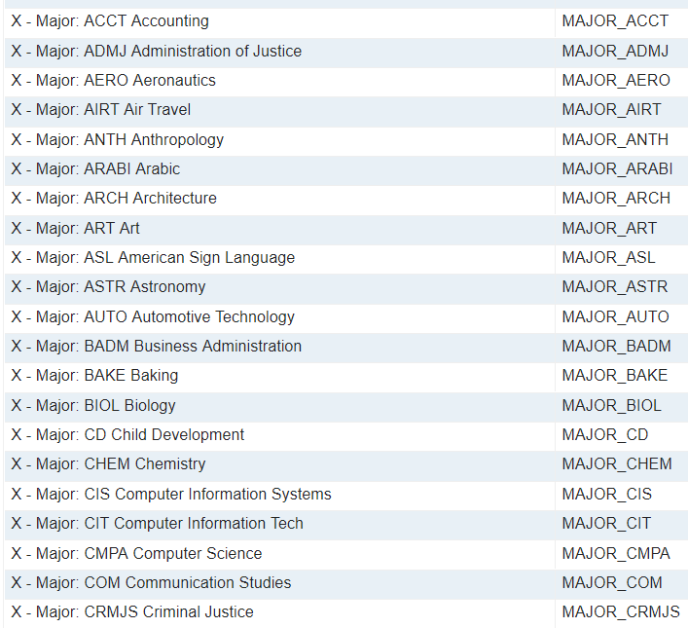

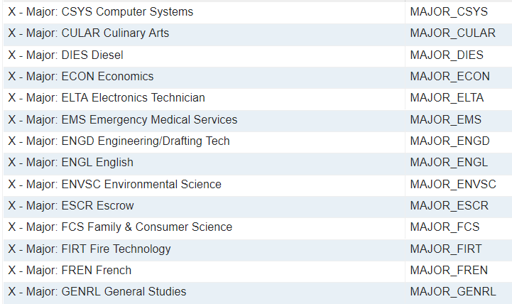

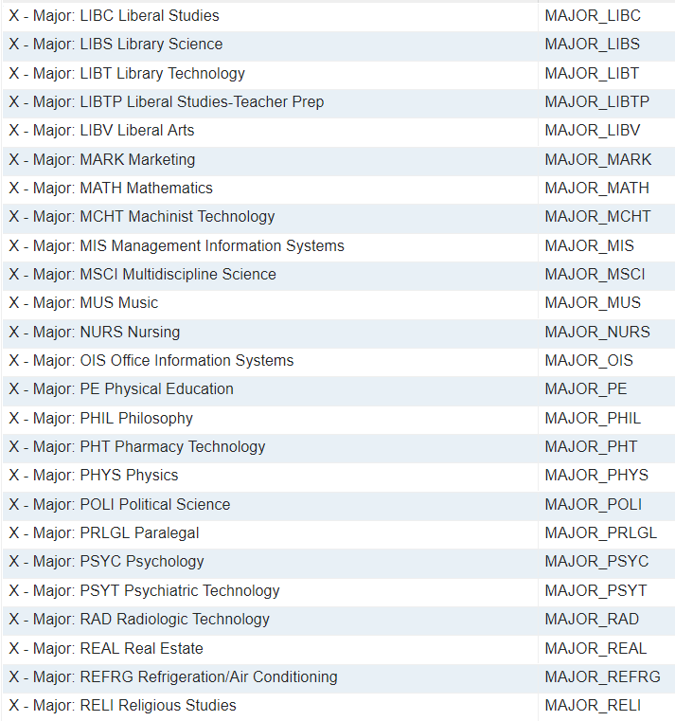
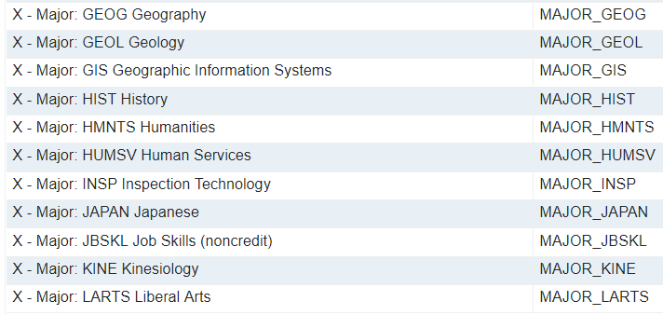

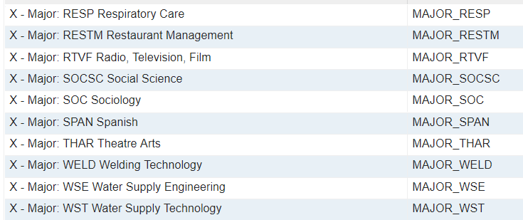

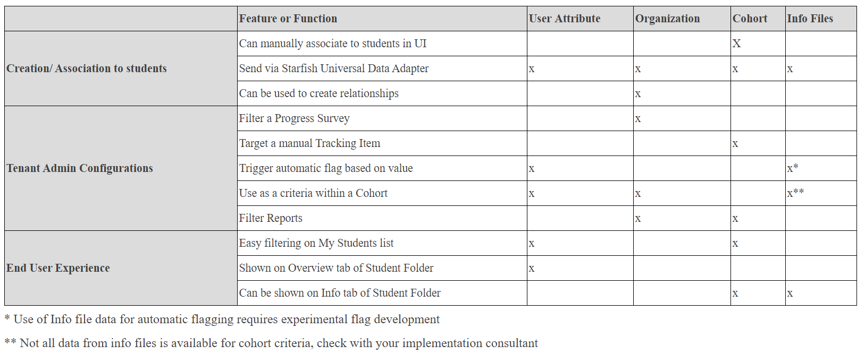
Attributes vs. Organizations vs. Cohorts Comparison Chart

FEATURE CONFIGURATION

Appointment Types
Name | Description | Permissions | Reasons | Speed notes
Advising | Use this type for Advising meetings. | Add and View Appointments: CARE Counselor, Valley Bound Commit Counselor, Guardian Scholars Counselor, First Yr Experience Counselor, Foster Youth Counselor, STEM Counselor, DSP&S Counselor, General Counselor, Veterans Counselor, Athletic Counselor, Tumaini Counselor, EOPS Counselor, Puente Counselor, CalWORKs Counselor | Complete withdrawal, course withdrawal, financial aid, first-year advising, general advising, graduation requirements, internship information, major advising, pre-registration, registration/class schedule, seek career advice, study abroad, tutoring | Academic status concern, address time management, adjustment to college, balancing academic goals and life goals, completed degree audit, discussed study skills, discussion of academic goals, discussion of career goals, family concerns, financial aid process, learning disability, registration for classes, review of campus resources, transfer credit review, transportation issues
Student Events | Use this type for the Events Attendance feature to record who attended orientation, a seminar, the career fair, etc. | Add and View Event: CARE Counselor, Valley Bound Commit Counselor, Guardian Scholars Counselor, First Yr Experience Counselor, Foster Youth Counselor, STEM Counselor, DSP&S Counselor, General Counselor, Veterans Counselor, Athletic Counselor, Tumaini Counselor, EOPS Counselor, Puente Counselor, CalWORKs Counselor | Student Orientation | Contact information given  Materials distributed
Teaching | Use this type for Instructor office hours. | Add and View Appointment: Instructor | Course add, discuss grades, discuss major or future career, discuss an assignment or project, general class questions, I want to be more involved, make up a test, quiz, or assignment, personal issues, review exam or quiz | Discuss major or future career, discussed an assignment or project, discussed grades, discussed how the student can become more involved, discussed study skills, exam prep, made up a test, quiz, or assignment, reference letter request, reviewed a test or quiz, reviewed coursework, tutoring

Custom Intake Questions
Question | Question Type
Desired Major | Short text
Do you have any concerns in the following areas? | Checkboxes
Do you provide frequent care for individuals other than yourself (e.g., children, siblings, parents, etc.)? | Yes or no
First name | Short text
How are you planning to pay for college? | Checkboxes
How certain are you about your career goals? | Multiple choice
How certain are you about your choice of major?
How confident are you in your ability to use a computer to complete assignments? | Multiple choice
How confident are you that you will have access to the internet when you need it to complete assignments? | Multiple choice
How many hours per week do you plan to work while enrolled in classes? | Multiple choice
How much flexibility do you have in your schedule to increase your study time if needed? | Multiple choice
How would you rate your past experience in Math? | Multiple choice
How would you rate your past experience in Reading? | Multiple choice
How would you rate your past experience in Science? | Multiple choice
How would you rate your past experience in Writing? | Multiple choice
If you chose "other" in the question above, please explain how you will be getting to campus. | Short text
If you chose "other" in the question above, please explain how you will be paying for college. | Short text
If you chose "other" in the question above, please explain the concerns you have. | Short text
If you chose "other" in the question above, please explain the services you would like to learn more about. | Short text
I know I will succeed in college because: | Long text
Last name | Short text
Preferred name | Short text
Student ID Number | Short text
What is the primary language you speak? | Short text
When you have to go to campus for class, how will you typically get there? (select all that apply) | Checkboxes
Where do you plan to take most of your classes this semester? | Multiple choice
Which of the following services would you like information about before you begin classes? (select all that apply) | Checkboxes

Degree Planner

Programs

Courses

Planning

Flag Thresholds
System-raised flags are raised based on data that comes to Starfish from the integrated learning management system. If some values, such as an assignment due date, are changed by the instructor but not changed in the online course, a large percentage of students could be flagged by the system for flags that depend on that data. To prevent students from being flagged when this happens, set a threshold percentage. When this is done, if the specified percent or greater of users in a class are flagged at once with the same flag, Starfish will assume that the data is faulty and will not flag all of the students in that instance. If students should always be flagged even in this situation, leave the threshold field blank

Threshold: 100%

Kiosks
Kiosks not currently being used.

Note Types
Name | Description | Creators (Can add and view)
Counseling Note | Used by counselors to document notes and comments related to academic advising. | Athletic Counselor, CARE Counselor, CalWORKs Counselor, Campus Leadership, DSP&S Counselor, EOPS Counselor, First Yr Experience Counselor, Foster Youth Counselor, General Counselor, Guardian Scholars Counselor, Honors Counselor, International Std Counselor, Left Lane Counselor, Middle College Counselor, Puente Counselor, STEM Counselor, Tumaini Counselor, Valley Bound Commit Counselor, Counselor, Veterans Counselor
DSP&S Confidential Notes | Notes specific to DSP&S that contain confidential information. | DSP&S Counselor and DSP&S Support Staff
Instructor and Counselor Note | Shared between instructors and counselors (and the student). | Athletic Coach, Instructor, Athletic Counselor, CARE Counselor, CalWORKs Counselor, Campus Leadership, DSP&S Counselor, EOPS Counselor, First Yr Experience Counselor, Foster Youth Counselor, General Counselor, Guardian Scholars Counselor, Honors Counselor, International Std Counselor, Left Lane Counselor, Middle College Counselor, Puente Counselor, STEM Counselor, Tumaini Counselor, Valley Bound Commit Counselor, Counselor, Veterans Counselor
Shared Campus Note | These notes are shared widely with all employee roles in Starfish (and the student). | All role-s (minus DP Tester, Evaluator, Researcher, Tech Team, TA)
Student and Instructor Note | Notes for you, the Instructor (and the student). | Instructor

Progress Surveys
Instructions for Surveys: “Please complete the following survey by selecting at least one of the options below, for each student. After you have checked the appropriate box(es), add the student's grade into (one of) the comment box(es), along with any other comments of concerns or accolades you have for them. ONLY hit submit after you have completed giving feedback for all of your students. If problems arise, email StarfishFaculty@craftonhills.edu”

When bulk adding courses, they need to be in the following format: C-ASL-101-05-2018FA
Routine Progress Surveys:
- “Academic Progress Surveys” survey the following populations:

  - Crafton Athletes (Chittenden, Grabow)
  - Crafton CalWORKs (Chavira,Rodriguez)
  - Crafton DSP&S (Milligan, Sierra)
  - Crafton EOPS/CARE (Chavira,Rodriguez)
  - Crafton Foster Youth (Chavira,Rodriguez)
  - Crafton Honors (Judy Cannon)
  - Crafton Probation Students (Bell, Orta)
  - Crafton Promise (Souts)
  - Crafton Veterans (Rush and Lisa Mills)

  - Valley Bound* (Sharaf Williams)
  - Valley EOPS/CARE (Maria Del Carmen Rodriguez)
  - Valley FYE* (Sharaf Williams)
  - Valley Foster Youth AND Valley Dreamers and Guardian Scholars* (Sharaf Williams)
  - Valley GenGo (Patty Quach)
  - Valley Middle College (Kimberly Wingson)

* Need to enter the following 6-8 specific courses (update from “cohort” section each semester):
Valley Bound, Valley Dreamers and Guardian Scholars, and Valley FYE: V-SDEV-103-03-2019SP, V-SDEV-103-01-2019SP, V-SDEV-103-05-2019SP, V-SDEV-103-07-2019SP, V-SDEV-103-13-2019SP, V-SDEV-103-94-2019SP, V-SDEV-103-93-2019SP
Surveys include the following flags and kudos: These Flags/Kudos differ from regular tracking items in the sense that they are attached to full messaging templates, rather than having the message inserted within the tracking item itself. To set these flags up, make sure that only one user can raise the item, but all other workflow remains consistent with other flags as shown later in this document.

Name of Flag | Status | Tracking Item
Progress Report - Prepared and Ready for Class | Enabled | Kudo
Progress Report - Positive Attitude and Effort | Enabled | Kudo
Progress Report - Outstanding Academic Performance | Enabled | Kudo
Progress Report - Showing Improvement | Enabled | Kudo
Progress Report - Recommend Tutoring | Enabled | Referral
Progress Report - Attendance/Tardy Concern | Enabled | Flag
Progress Report - Missing/Late Assignments | Enabled | Flag
Progress Report - Low Quiz/Test Scores | Enabled | Flag
Progress Report - Other Concern | Enabled | Flag
Progress Report - Struggles with Material | Enabled | Flag

Three surveys are sent out each semester based on course length.
Crafton Hills College’s dates are as follows:
- The 5 week session progress reports will open during the third week of classes
- The 7-8 week session progress reports will open during the fourth and fifth week of classes
- 13/15/17 week classes will remain the same as what we have now, with their progress reports open during the middle months: October and March.
* CHC progress reports should exclude EMS 021, 022, 023, 025, and 066

- CHC “Respiratory Midterm Grade and Progress Report” surveys all C-RESP classes, with the exception of C-RESP-050, 109A/B, 133, 137, and 236. This should leave the following courses to survey: C-RESP-130, C-RESP-131, C-RESP-132, C-RESP-134, C-RESP-135, C-RESP-136, C-RESP-138, C-RESP-139, C-RESP-234, C-RESP-235, C-RESP-237, C-RESP-238
Survey includes the following flag and kudo:
- Keep up the Good Work
- Cause for Concern (other concern flag)
* One survey is sent out each semester during dates chosen by the respiratory leads.

Messaging Templates for Survey Announcement, Deployment, Reminders, Submission & Closing

Announcement | Dear [Recipient First Name],  It's that time! [Institution Name] EOPS, Promise, and special population Progress Reports are coming up!  On [Deployment Date], you will be asked to respond to a Starfish Progress Report for the following course sections:  [Survey List]  To access the Progress Reports for your course(s):  - Login to Starfish (using your district username and password) at https://sbccd.starfishsolutions.com/starfish-ops  - A link to your Outstanding Surveys will be displayed at the top of your Starfish homepage.  - Once you reach the progress report grid, simply check the box next to the particular student's name for whom you would like to report progress. You will have options to add comments. If you have information about the student's current grade in class, you can enter this into the comments boxes as well.  - Click Submit ONLY when you have entered information for all students listed in that particular class. If you don't have any progress to report, it is important that you click Submit, so we know you reviewed the survey. You will receive a confirmation email.  - Items you raise will be sent to the student and will be addressed by the appropriate individuals from our institution.  What if I need assistance?  For a short video tutorial on how to complete this Progress Report, please click on the following link: https://youtu.be/Jy3DTkM6sxU  For questions or troubleshooting, email StarfishFaculty@craftonhills.edu  We appreciate your dedication to student success at our institution. Thank you again for your participation!  The Progress Report will be available until [Closure Date].‌
Deployment | ‌Dear [Recipient First Name],  Progress Reports for EOPS, Promise, and other campus special population programs is now open! You will have until [Closure Date] to complete your progress reports (one for each section you teach). You do not need to wait for paper reports from students; all students who need a progress report completed are preloaded in Starfish.  To access the Progress Reports for your course(s):  - Login to Starfish (using your district username and password) at https://sbccd.starfishsolutions.com/starfish-ops  - A link to your Outstanding Surveys will be displayed at the top of your Starfish homepage.  - Once you reach the progress report grid, simply check the box next to the particular student's name for whom you would like to report progress. You will have options to add comments. If you have information about the student's current grade in class, you can enter this into the comments boxes as well.  - Click Submit ONLY when you have entered information for all students listed in that particular class. If you don't have any progress to report, it is important that you click Submit, so we know you reviewed the survey. You will receive a confirmation email.  - Items you raise will be sent to the student and will be addressed by the appropriate individuals from our institution.  You have [Incomplete Count] surveys which need to be completed.  Outstanding Surveys:  [Survey List]  Your responses will help us know which students to reach out to and offer help.  What if I need assistance?  For a short video tutorial on how to complete this Progress Report, please click on the following link: https://youtu.be/Jy3DTkM6sxU  For questions or troubleshooting, email StarfishFaculty@craftonhills.edu  Thank you again for taking the time to provide valuable feedback to our students!  ‌
1st reminder | ‌Dear [Recipient First Name],  The following Starfish Progress Surveys expire on [Closure Date]!  [Survey List]  Recently, you received an email from Starfish with instructions on how to submit these surveys. This should only take a few minutes and your responses will help us determine which students to reach out to and offer help. We have copied and pasted the instructions here in case they were lost in your email inbox :)  To access the Progress Reports for your course(s):  - Login to Starfish (using your district username and password) at https://sbccd.starfishsolutions.com/starfish-ops  - A link to your Outstanding Surveys will be displayed at the top of your Starfish homepage.  - Once you reach the progress report grid, simply check the box next to the particular student's name for whom you would like to report progress. You will have options to add comments. If you have information about the student's current grade in class, you can enter this into the comments boxes as well.  - Click Submit ONLY when you have entered information for all students listed in that particular class. If you don't have any progress to report, it is important that you click Submit, so we know you reviewed the survey. You will receive a confirmation email.  - Items you raise will be sent to the student and will be addressed by the appropriate individuals from our institution.  What if I need assistance?  For a short video tutorial on how to complete this Progress Report, please click on the following link: https://youtu.be/Jy3DTkM6sxU  For questions or troubleshooting, email StarfishFaculty@craftonhills.edu  We appreciate your dedication to student success at our institution. Thank you again for your participation!
2nd reminder | ‌Dear [Recipient First Name],  The following Starfish Progress Surveys expire on [Closure Date] ! This will be your last reminder.  [Survey List]  Recently, you received an email from Starfish with instructions on how to submit these surveys. This should only take a few minutes and your responses will help us determine which students to reach out to and offer help. We have copied and pasted the instructions here in case they were lost in your email inbox :)  To access the Progress Reports for your course(s):  - Login to Starfish (using your district username and password) at https://sbccd.starfishsolutions.com/starfish-ops  - A link to your Outstanding Surveys will be displayed at the top of your Starfish homepage.  - Once you reach the progress report grid, simply check the box next to the particular student's name for whom you would like to report progress. You will have options to add comments. If you have information about the student's current grade in class, you can enter this into the comments boxes as well.  - Click Submit ONLY when you have entered information for all students listed in that particular class. If you don't have any progress to report, it is important that you click Submit, so we know you reviewed the survey. You will receive a confirmation email.  - Items you raise will be sent to the student and will be addressed by the appropriate individuals from our institution.  What if I need assistance?  For a short video tutorial on how to complete this Progress Report, please click on the following link: https://youtu.be/Jy3DTkM6sxU  For questions or troubleshooting, email StarfishFaculty@craftonhills.edu  We appreciate your dedication to student success at our institution. Thank you again for your participation! ‌
Submission | ‌Dear [Recipient First Name],  Thank you for completing the following Starfish Progress Report(s):  [Survey List]  You raised the following tracking items:  [Intervention List]  If you forgot to provide feedback on any students, want to provide more feedback, or accidently hit "Submit" too early, please login to Starfish and click on "students" in the toolbar. Once you see all your students, make sure you select the class(es) you need to submit feedback for in the "connections" drop down. Then in the "cohorts" drop down, select all of the following groups: Crafton CalWORKs, Crafton EOPS/CARE, Crafton Foster Youth, Crafton Promise, and Crafton Veterans. This will take care of almost all students that were part of the progress survey (since we cannot disclose DSPS and Probation students). Then you can raise flags and/or give kudos to these students individually or in groups if you check the boxes by their names.  We appreciate your dedication to student success at our institution.  Thank you again for your participation!
Closure | ‌Dear [Recipient First Name]  The following Starfish Progress Report is now closed: [Survey Name]  If you did not get a chance to participate, or you have new concerns regarding your students, you can raise these individually in Starfish at any time by logging in to Starfish, with your WebAdvisor credentials at http://sbccd.starfishsolutions.com/starfish-ops  Once you login to Starfish, click on "students" in the toolbar. Make sure you select the class(es) you need to submit feedback for in the "connections" drop down. Then in the "cohorts" drop down, select all of the following groups: Crafton CalWORKs, Crafton EOPS/CARE, Crafton Foster Youth, Crafton Promise, and Crafton Veterans. This will take care of almost all students that were part of the progress survey (since we cannot disclose DSPS and Probation students). Then you can raise flags and/or give kudos to these students individually or in groups if you check the boxes by their names.  If you need assistance in doing so, visit your campus's Starfish Resource page at  Crafton Hills College: https://www.craftonhills.edu/current-students/counseling/starfish/index.php  San Bernardino Valley College: https://www.valleycollege.edu/student-services/counseling/starfish/index.php  or email StarfishFaculty@craftonhills.edu (Crafton Only).  Thank you for your continued participation in this effort to promote student success.

Raise Your Hand
Provide a description of how the Raise Your Hand feature will benefit users and what resources are available to them through it.
“Need assistance? Complete the form below to get started. We encourage you to be proactive in seeking help on our campus. We believe you can be successful and want to help you get there!”

X Display the Raise Your Hand form below the text that is provided above.

Services
Service Description, hours, location, and contacts often change. For this reason, only the service titles are listed here.

- Campus Police
- CHC Admissions and Records
- CHC Career Center
- CHC COACH Cupboard
- CHC Counseling
- CHC Disabled Students Programs and Services
- CHC Diversity and Inclusion
- CHC EOPS/CARE/CalWORKs
- CHC Financial Aid
- CHC Health and Wellness
- CHC International Student Services
- CHC Library
- CHC REACH
- CHC Safe Space
- CHC Student Life
- CHC Student Success
- CHC Tutoring
- CHC University Transfer Center
- CHC Veteran’s Center
- SBVC Admissions and Records
- SBVC Counseling
- SBVC Disabled Students Programs and Services
- SBVC Financial Aid
- SBVC Health and Wellness
- SBVC Library
- SBVC Student Life
- SBVC Transfer Center
- SBVC Tutoring
- SBVC Veteran’s Center
- SBVC Writing Center

*Reach out to each department every semester to check for changes.

Speed Notes
Speed Notes allow advisors and other service providers to quickly take notes on their meetings with students by checking off the activities they performed and discussion points from the meeting. Create a repository of activities commonly completed in different types of meetings at your institution. Next, add the activities used for different types of meetings to the related Appointment Types.

Name | Category | Associated Appointment Type
Academic status concern | Academic Planning | Advising
Addressed time management | Counseling | Advising
Adjustment to college | Counseling | Advising
Balancing academic goals and life goals | Counseling | Advising
Complete degree audit | Academic Planning | Advising
Contact information given | General | Student Events
Discussed an assignment or project | Coursework Assistance | Teaching
Discussed grades | Academic Planning | Teaching
Discussed how the student can become more involved | Other | Teaching
Discussed major or future career | Academic Planning | Teaching
Discussed study skills | Counseling | Advising, Teaching
Discussion of academic goals | Academic Planning | Advising
Discussion of career goals | Academic Planning | Advising
Exam prep | Coursework Assistance | Teaching
Family concerns | Counseling | Advising
Financial aid process | Financial Aid | Advising
Learning disability | Counseling | Advising
Made up test, quiz, or assignment | Coursework Assistance | Teaching
Materials distributed | General | Student Events
Reference letter request | Career Planning | Teaching
Registration for classes | Academic Planning | Advising
Review of campus resources | Counseling | Advising
Reviewed a test or quiz | Coursework Assistance | Teaching
Reviewed coursework | Coursework Assistance | Teaching
Transfer credit review | Academic Planning | Advising
Transportation issues | Counseling | Advising
Tutoring | Coursework Assistance | Teaching

Student Intake
A form can be created to record data about students during the Intake process. Create the form below, selecting the questions that should be included from the question bank. The form can be divided into sections by adding section headers, and instructional text can be added throughout to give providers guidance on completing the form.

Spring 2018 Student Intake Form
Data has shown that successful students are those who know where they need help and take advantage of the resources offered. Your honest responses to these questions will help us provide you with early support. This survey will only take approximately 3-5 minutes to complete. Your responses will only by shared with appropriate staff who may contact you to provide assistance and resources.

First Name

Last Name

Preferred Name

Student ID Number

What is the primary language you speak?

Where do you plan to take most of your classes this semester?
Crafton Hills College
San Bernardino Valley College

How certain are you about your career goals?
Very certain
Moderately certain
Slightly certain
Not at all certain

How certain are you about your choice of major?
Very certain
Moderately certain
Slightly certain
Not at all certain

How would you rate your past experience in Math?
Not challenging at all
Slightly challenging
Moderately challenging
Very challenging

How would you rate your past experience in Reading?
Not challenging at all
Slightly challenging
Moderately challenging
Very challenging

How would you rate your past experience in Writing?
Not challenging at all
Slightly challenging
Moderately challenging
Very challenging

How would you rate your past experience in Science?
Not challenging at all
Slightly challenging
Moderately challenging
Very challenging

How confident are you in your ability to use a computer to complete assignments?
Very confident
Moderately confident
Slightly confident
Not confident at all

How confident are you that you will have access to the internet when you need it to complete assignments?
Very confident
Moderately confident
Slightly confident
Not confident at all

How are you planning to pay for college?
Self-funded (job, savings, etc.) or Parents
Financial Aid/FAFSA (grants, loans, work study)
Veterans Education Benefits
Unsure
Other (i.e., Employer Funding, Scholarships, etc.)
If you chose "other" in the question above, please explain how you will be paying for college.

When you have to go to campus for class, how will you typically get there? (select all that apply)
My own vehicle
Bus
Ride with family or friends
Walk/bicycle
Taxi or Uber/Lyft
I am taking online classes
Unsure/I do not have reliable transportation
Other
If you chose "other" in the question above, please explain how you will be getting to campus.

Do you provide frequent care for individuals other than yourself (e.g., children, siblings, parents, etc.)?
Yes
No

Do you have any concerns in the following areas?
Housing or homelessness
Food insecurity or concern where your next meal will come from
Other
Not Applicable

If you chose "other" in the question above, please explain the concerns you have.

How many hours per week do you plan to work while enrolled in classes?
0
1-9
10-19
20-29
30-39
40+

How much flexibility do you have in your schedule to increase your study time if needed?
A lot of flexibility
A moderate amount of flexibility
Only a little flexibility
No flexibility at all

Which of the following services would you like information about before you begin classes? (select all that apply)
Academic tutoring
Accommodations/Disabled Student Programs and Services
Computer tutorial - Academic (e.g., navigating SBCCD systems, using classroom software, etc.)
Computer tutorial - General (e.g., email, file/folder organization, saving documents, etc.)
Childcare
Community resources (e.g., housing, food banks, social service agency information, or referrals)
Extracurricular activities (e.g., student organizations, student government, athletics, etc.)
Financial Coaching and budgeting
Mentoring by Master Students
Navigating campus/Campus tours
On-Campus employment
Personal counseling (e.g., anxiety, depression, etc.)
Purchasing textbooks (or possible book loans) and supplies
Study abroad
Veteran's Services
Wellness/Campus Health Center Options
Other

If you chose "other" in the question above, please explain the services you would like to learn more about.

I know I will succeed in college because:

Student Intake Intervention Matrix
Intake Survey Question | Response Trigger for Referral | Referral To: | Communication By: | Timing/Frequency
What is the primary language you speak? | None | None | None | None
How certain are you about your career goals? | Slightly certain, Not certain at all | Career Center |  | Biweekly
How certain are you about your choice of major? | Slightly certain, Not certain at all |  |  | Biweekly
How would you rate your past experience in Math? | Moderately challenging,  Very challenging | None | Tutoring Center | Semester start
How would you rate your past experience in Reading? | Moderately challenging,  Very challenging | None | Tutoring Center | Semester start
How would you rate your past experience in Writing? | Moderately challenging,  Very challenging | None | Tutoring Center | Semester start
How would you rate your past experience in Science? | Moderately challenging,  Very challenging | None | Tutoring Center | Semester start
How confident are you in your ability to use a computer to complete assignments? | Slightly confident,  Not confident at all |  |  | 4 weeks prior to semester start
How confident are you that you will have access to the internet when you need it to complete assignments? | Slightly confident,  Not confident at all |  |  | 4 weeks prior to semester start
How are you going to pay for college? | Self-funded or parents –  No payment method in place | Bursar |  | Semester start
How are you going to pay for college? | Financial Aid – No FAFSA on file | Financial Aid |  | 8 weeks prior to semester start
How are you going to pay for college? | Veterans Education Benefits – No paperwork on file | Veteran’s Center |  | Biweekly
How are you going to pay for college? | Unsure |  |  | Biweekly
When you have to go to campus for class, how will you typically get there? | Unsure / I do not have reliable transportation | Student Life office |  | Biweekly
Do you provide care for individuals other than yourself? | None | None | None | None
Do you have any concerns in the following areas? | Depends on answer | Depends on answer | REACH, COACH, Student Success | 8 weeks prior to semester start
How many hours per week do you plan to work while enrolled in classes? | None | None | None | None
How much flexibility do you have in your schedule to increase your study time if needed? | Only a little flexibility,  No flexibility at all | Student Success Advisors |  | 4 weeks prior to semester start
I know I will succeed in college because: | None | None | None | None
Information Requested | Response Trigger for Referral | Referral To: | Communication By: | Timing/Frequency
More Information: Academic Tutoring | None | None | Tutoring Center | Semester start
More Information: DSP&S | None | None | DSP&S | Biweekly
More Information: Computer Tutorial - Academic | None | None | Tech Center | 2 weeks prior to semester/weekly
More Information: Computer Tutorial -General | None | None | Tech Center | 2 weeks prior to semester/weekly
More Information: Childcare | None | None | Student Success Advisors and Campus Childcare | Biweekly
More Information: Community Resources | None | None | Student Success Advisors | Biweekly
More Information: Extracurricular Activities | None | None | Student Life Office | Semester start
More Information: Financial Coaching and Budgeting | None | None | Student Success Advisors,  Financial Aid and Career Center | Biweekly
More Information: Mentoring by Master Students | None | None | Student Success Advisors | Biweekly
More Information: Navigating Campus/ Campus Tour | None | None | Student Life | 4 weeks prior to semester/weekly
More Information: On-Campus Employment | None | None | Student Success Advisors | Semester start
More Information: Personal Counseling | None | None | Health and Wellness Center | Biweekly
More Information: Purchasing Textbooks and Materials | None | None | Student Success Advisors and Bookstore | 4 weeks prior to semester/weekly
More Information: Study Abroad | None | None | Jeff Schmidt (x3342) | Semester start
More Information: Veteran’s Services | None | None | Veteran’s Center | 2 weeks prior to semester/weekly
More Information: Wellness/ Campus Health Center | None | None | Health and Wellness Center | Semester start

Project Hope Intake Form
You know what’s happening in college. Help make your college the best it can be for you and your friends. As part of a research initiative to benefit your institution, please tell us about your experiences by completing the #RealCollege questionnaire below. It’ll take a few minutes but we think your story is important.

Answering the following questions completely voluntary, you can stop answering them at any time. Please click “Yes” below and answer the following questions.
1. Do you consent to participate? (Required)
- Yes
- No (scroll down and select Save to Continue)

These next questions are about the food you have eaten in your household in the last 30 days, and whether you were able to afford the food you need.
Over the last 30 days, how true would you say the following statements are?
2. The food that I bought just didn't last and I didn't have money to get more.
- Often true
- Sometimes true
- Never true
3. I couldn't afford to eat balanced meals.
- Often true
- Sometimes true
- Never true
4. Over the last 30 days, did you ever cut the size of your meals or skip meals because there wasn't enough money for food?
- Yes
- No
5. If yes to #4, then: In the last 30 days, how often did you ever cut the size of your meals or skip meals because there wasn't enough money for food?
- Once
- Twice
- Three times
- Four times
- Five times
- More than five times
6. In the last 30 days, did you ever eat less than you felt you should because there wasn't enough money for food?
- Yes
- No
7. In the last 30 days, were you ever hungry, but didn't eat, because there wasn't enough money for food?
- Yes
- No

Now we'd like to learn a bit about what your life is like these days.
In the past 12 months, did you experience any of the following:
8. Been unable to pay or underpaid your rent or mortgage?
- Yes
- No
9. Received a summons to appear in housing court?
- Yes
- No
10. Not paid the full amount of a gas, oil, or electricity bill?
- Yes
- No
11. Had an account default or go into collections?
- Yes
- No
12. Moved in with other people, even for a little while, because of financial problems?
- Yes
- No
13. Lived with others beyond the expected capacity of the house or apartment?
- Yes
- No
14. Was there a rent or mortgage increase that made it difficult to pay?
- Yes
- No
15. Did you leave your household because you felt unsafe?
- Yes
- No
16. In the past 12 months, how many times have you moved?
- None
- Once
- Twice
- Three times
- Four times
- Five or more times
17. In the past 12 months, have you ever been homeless?
- Yes
- No
In the past 12 months, have you slept in any of the following places:
18. In campus or university housing?
- Yes
- No
19. In a sorority/fraternity house?
- Yes
- No
20. In a rented or owned house, mobile home, or apartment (alone or with roommates or friends)?
- Yes
- No
21. In a rented or owned house, mobile home or apartment with your family (parent, guardian, or relative)?
- Yes
- No
22. At a shelter?
- Yes
- No
23. In a camper or RV?
- Yes
- No
24. Temporarily stayed with a relative or friend, or couch surfed until finding other housing?
- Yes
- No
25. Temporarily at a hotel or motel without a permanent home to return to (not on vacation or business travel)?
- Yes
- No
26. In transitional housing or an independent living program?
- Yes
- No
27. At a group home such as halfway house or residential program for mental health or substance abuse?
- Yes
- No
28. At a treatment center (such as detox, hospital, etc.)?
- Yes
- No
29. In an outdoor location such as street, sidewalk, or alley, bus or train stop, campground or woods, park, beach, or riverbed, under bridge or overpass?
- Yes
- No
30. In a closed area/space with a roof not meant for human habitation such as abandoned building, car or truck, van, encampment or tent, or unconverted garage, attic, or basement?
- Yes
- No

Success Plan Types

Plan Type
CHC New Students' Success Plan (0 units)
CHC Success Plan for Students with 0-15 units completed
CHC Success Plan for Students with 16-30 units completed
CHC Success Plan for Students with 31-45 units completed
CHC Success Plan for Students with 45-60 units completed
SBVC Success Plan for Students with 0-15 units completed (in progress)
SBVC Success Plan for Students with 16-30 units completed (in progress)
SBVC Success Plan for Students with 31-45 units completed (in progress)
SBVC Success Plan for Students with 46-60 units completed

Success Plan Privileges

Role | Raise | View | Manage | Assign | Email
Athletic Director I |  | X
Athletic Director II |  | X
Campus Leadership |  | X | X | X
Student |  | X
Flag Triage |  | X | X | X
General Counselor |  | X | X | X
Std Services Div Supp Staff |  | X
Student Success Support |  | X | X | X

- CHC Success Plans: Students need to be filtered and assigned these success plans: New students (0 units), 1-15 units, 16-30 units, 31-45 units, 46-60 units
  - CHC: Counselors will assign when they meet with students.

Tracking Rules

FLAGS

A list of the current flags includes:

Name of Flag | Status | Flag Type | Description
3-Flags | Enabled |  | SYSTEM RAISED: This flag will be raised automatically when a student has three active flags in their file. This flag will be cleared automatically when the student's other flags are cleared, and they fall below the three-flag threshold.
30+ CSU Transferable Units Completed | Enabled |  | SYSTEM RAISED: Message sent to Crafton students when flagged for student who has completed 30+ CSU transferable units.
30+ UC Transferable Units Completed | Enabled |  | SYSTEM RAISED: Message sent to Crafton students when flagged for student who has completed 30+ UC transferable units.
60 Transferable Units Completed But Goal Not Met | Disabled | Counseling | SYSTEM RAISED. Student has completed 60 transferable units and has not reached academic goal.
Attendance/Tardy Concern | Enabled | Academic | Raise this when a student isn't attending class regularly or is often late.
Automatic Canvas ___ Day Inactivity Notification | Enabled | Academic | SYSTEM RAISED. Automatic flag raised when students have not logged in to Canvas in ____ consecutive days.
Automatic Flags for Missing Assignments | Enabled | Academic | SYSTEM RAISED. If ( # ) of assignments are missing for more than ( # ) days, a flag will be raised.
Automatic Low Grade Notification (___% or less) | Enabled | Academic | SYSTEM RAISED. Flag is raised when student's grade drops below ___% in Canvas.
Financial Aid Warning | Disabled | Counseling | SYSTEM RAISED. Student has reached 60 units and will need to complete Financial Term Dismissal.
Food and/or Housing Assistance (Attribute Based on Project Hope responses) | Disabled | Counseling | SYSTEM RAISED. Flag is raised when a student has food/housing insecurities attributes based on their responses to the Project Hope Intake Form.
Graduation eligibility | Disabled | Counseling | This message is emailed to students who are eligible to graduate with an Associate Degree and/or Certificate.
In Danger of Failing | Enabled | Academic | Raise this when a student is in danger of failing a course and there is a slim chance of them successfully completing the course.
I Need Help, But Don't Know Where To Start | Enabled | Student | STUDENT RAISED. Select this option when you know you need help but are not sure where to start. A counselor will be notified. Please also enter the best way to contact you, including your phone number and email address.
I Need Help In A Course | Enabled | Student | STUDENT RAISED. Select this option when you need assistance in a course. Your instructor will be notified. Don't forget to include your current email address and phone number.
I Need Help Paying For College | Enabled | Student | STUDENT RAISED. Select this option when you need assistance with financial aid. An advisor from the financial aid office will be notified. Let us know how you prefer to be contacted (email or phone) as well as your latest contact information.
I Need Help with Accessing Technology | Enabled | Student | STUDENT RAISED. Select this option when you need access to, or assistance in acquiring specific technology that is required for your courses.
I Need Help with Food and/or Housing | Enabled | Student | STUDENT RAISED. Select this option when you need assistance with food and/or housing. Let us know how you prefer to be contacted (email or phone) as well as your latest contact information, and we will reach out to you with resources.
Lack of Preparation | Enabled | Academic | Student is not prepared for class and/or does not have required course materials.
Low Quiz/Test Scores | Enabled | Academic | Raise this when a student receives a poor grade on a quiz or test.
Missing/Late Assignments | Enabled | Academic | Raise this flag when a student shows a pattern of missing or late assignments.
Other Concern | Enabled | Academic | Flag designed to inform those within a student's success network regarding a general academic concern.
Progress Report- Attendance/Tardy Concern | Enabled | Academic | Raise this when a student isn't attending class regularly or is often late.
Progress Report- Low Quiz/Test Scores | Enabled | Academic | Raise this when a student receives a poor grade on a quiz or test.
Progress Report- Missing/Late Assignments | Enabled | Academic | Raise this flag when a student shows a pattern of missing or late assignments.
Progress Report- Other Concern | Enabled | Academic | Flag designed to inform those within a student's success network regarding a general academic concern.
Progress Report- Struggles with Material | Enabled | Academic | Student is having difficulty with course material. May be caused by learning challenges, lack of study skills, or need for additional support.
Struggles with Material | Enabled | Academic | Student is having difficulty with course material. May be caused by learning challenges, lack of study skills, or need for additional support.
Transfer Ready | Enabled | Counseling | This message is sent to students who have between 30-45 transfer units.
Transfer Ready | Disabled | Counseling | SYSTEM RAISED. Student has completed (or is currently enrolled in) 30-45 transferable units.
Tutoring Notification | Enabled | Counseling | This message is sent to all students at the start of each semester to utilize the Tutoring Center.
Unsatisfactory Academic Progress | Disabled | Counseling | SYSTEM RAISED. Student has failed to successfully complete 50% of attempted units.
Urgent Concern | Enabled | Academic | Select this flag to address a specific academic concern that needs to be addressed, and followed up on, asap.

Enabled Academic Flag privileges (with few exceptions)

Role | Raise | View | Manage | Assign | Email
Athletic Director I |  | X
Athletic Director II |  | X
Campus Leadership |  | X | X | X
Flagged Student |  | X |  |  | X
Flag Triage |  | X | X | X
General Counselor |  | X | X | X
Instructor (course context) | X | X | X | X
Std Services Div Supp Staff |  | X
Student Success Support |  | X

Automatic Flag Privileges

Role | View | Manage | Assign | Email
Breanna Andrews | X | X | X
Athletic Director I | X
Athletic Director II | X
Campus Leadership | X
Flagged Student | X |  |  | X
Flag Triage | X |  | X
General Counselor | X |  | X
Instructor (course context) | X |  |  | X
Student Support Staff | X
Std Services Div Supp Staff | X

Automatic Flags for Low Grades (this chart is used to organize auto low-grade flags)

 | Start Date | % Threshold | Course/Section | Faculty Member

Automatic Flag for Canvas Inactivity (this chart is used to organize auto inactivity flags)

 | Start Date |  | End Date | # Days of Inactivity | Course/Section | Faculty Member

KUDOS

A list of the current kudos includes:

Name of Kudo | Status | Kudo Type | Description
Completed Comprehensive Student Education Plan (SEP) | Disabled | Counseling | SYSTEM RAISED. Comprehensive Student Education Plan (SEP) Completed.
Completed Golden 4 | Disabled | Counseling | SYSTEM RAISED. Completed Golden 4: English Composition, Critical Thinking, Communication, and Transferable Math.
Deans’ List | Disabled | Counseling | SYSTEM RAISED. Student has maintained a …. GPA.
Extracurricular Activity | Enabled | All can raise & see | Participation in extracurricular activities in the form of outreach, community events, volunteer work “Engagement”.
Increased GPA by 1.0 | Disabled | Counseling | SYSTEM RAISED. Students GPA increased by 1.0.
Keep Up the Good Work | Enabled | All can raise & see | Raise this kudo for students who are performing well.
Kudos to You | Enabled | All can raise & see | Use this Kudos when none of the other kudos apply and you would like to send the student a personal kudos.
Outstanding Academic Performance | Enabled | Academic & Counseling | Raise this kudo when a student has outstanding academic performance.
Positive Attitude and Effort | Enabled | All can raise & see | Student demonstrates a positive attitude and is engaged in class, is respectful, comes prepared, shows initiative, and completes all assignments.
Positive Peer Support | Enabled | All can raise & see | Student contributes positively to their peers’ learning experience.
Prepared and Ready for Class Sessions | Enabled | Academic | Student is prepared and ready for class each session.
Progress Report - Outstanding Academic Performance | Enabled | Progress Report | Raise this kudo when a student has outstanding academic performance.
Progress Report - Positive Attitude and Effort | Enabled | Progress Report | Student demonstrates a positive attitude and is engaged in class, is respectful, comes prepared, shows initiative, and completes all assignments.
Progress Report - Prepared and Ready for Class Sessions | Enabled | Progress Report | Student is prepared and ready for class each session.
Progress Report - Showing Improvement | Enabled | Progress Report | Raise this kudo when a student has shown improvement.
Showing Improvement | Enabled | All can raise & see | Raise this kudo when a student has shown improvement.
Transfer Ready | Enabled | Counseling | SYSTEM RAISED. Sent to students who have achieved 35-45 transfer units.

Enabled Kudo Privileges

* Course specific Kudos will only be created by Instructors (Outstanding Academic Performance and Prepared and Ready for Class Sessions)

Role | Create | View | Manage | Email
Breanna Andrews | X | X | X
Athletic Director I | X | X
Athletic Director II | X | X
Campus Leadership | X | X
Student |  | X |  | X
Flag Triage | X | X
General Counselor | X | X
Instructor (course context) | X | X
Std Services Div Supp Staff | X | X
Student Success Support | X | X

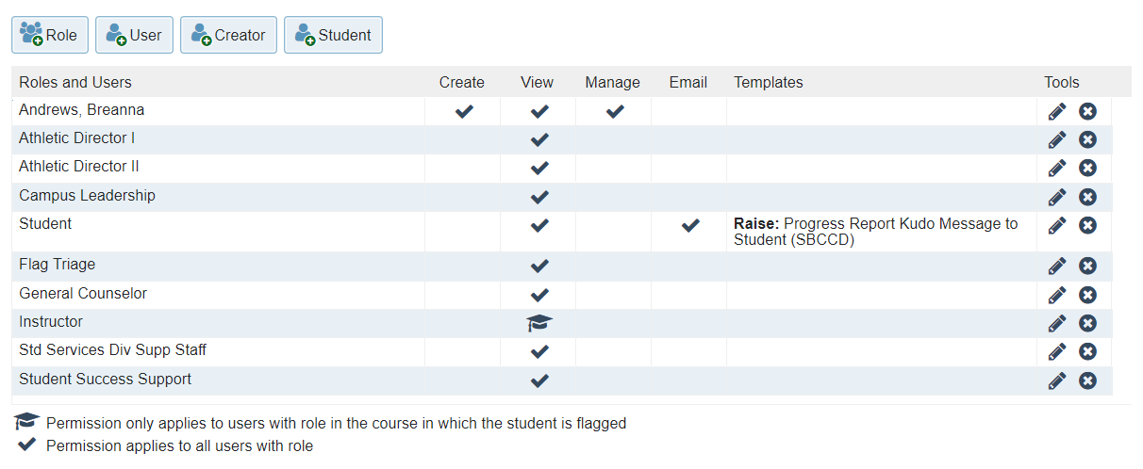
Progress Report Kudos have the following Privileges:

REFERRALS

A list of the current Referrals includes:

Name of Referral | Status | Description
Access to Technology | Enabled | Use this to refer students to the library where they can borrow a Chromebook and or Wi-Fi hotspot.
Admissions and Records Referral | Enabled | Use this to refer a student to Admissions and Records
CalWORKs Referral | Enabled | Use this to refer a student to the CalWORKs office
Career Center Referral | Enabled | Use this to refer a student to the Career Center on campus.
CARE Referral | Enabled | Use this to refer a student to the CARE (Cooperative Agencies Resources for Education) office
Counseling Referral | Enabled | Use this to refer a student to the Academic Counseling office. For emotional and behavioral health concerns at CHC, please use the Student of Concern Referral Form at https://bit.ly/2wBUnSa . For emotional concerns at SBVC, please contact Mental Health Services at https://bit.ly/2wDfSCd
DSP&S Referral | Enabled | Use this referral only after having a conversation with a student who has indicated that they would like to look into services offered by the DSPS (Disabled Students Programs and Services) office.
EOPS Referral | Enabled | Use this to refer a student to the EOPS (Extended Opportunity Programs and Services) office
Financial Aid Referral | Enabled | Use this to refer a student to the Financial Aid office
Health Center Referral | Enabled | Use this to refer a student to the Health Center
Honors Referral | Enabled | Refer a student to the honors program when you feel they are qualified to take part in the program.
Library and Research Referral | Enabled | Use this to refer a student to the library for assistance conducting research.
REACH Referral (CHC only) | Enabled | When you suspect a student is homeless or may benefit from some additional assistance/guidance, refer them to talk with our REACH specialists.
Referral to become a tutor | Enabled | Use this referral to refer a student to apply to be a tutor for your discipline in the tutoring center
Student Life Referral | Enabled | Use this to refer a student to the Student Life Office
Student Success Referral | Enabled | Use this to refer a student to see as Student Success Counselor to go over services that the college offers.
Technology Access Referral | Enabled | Refer students to the library when specific technology is needed for the course and the student has expressed a need for access to, or assistance in acquiring specific technology that is required for your courses.
Testing Center Referral | Disabled | Refer students to the Testing Center when they need to make up an assessment or take a course challenge.
Transfer Center Referral | Enabled | Use this to refer a student to the Transfer Center
Tutoring Referral | Enabled | Use this to refer a student to the Tutoring Center
Veteran’s Center Referral | Enabled | Use this to refer a student to the Veteran’s Center
Writing Center Referral (SBVC only) | Enabled | Use this to refer a student to the Writing Center. For SBVC only. For CHC writing center, refer students to the tutoring center.

Enabled Referral privileges (with few exceptions)

Role | Raise | View | Manage | Assign | Email
* Specific counselor if applicable | X | X | X | X
Campus Leadership | X | X | X | X
Flagged Student |  | X |  |  | X
Flag Triage | X | X | X | X
General Counselor | X | X | X
Instructor (course context) | X | X | X | X
Student Support Staff | X | X | X | X
Std Services Div Supp Staff |  | X

Referrals with limited viewing privileges include referrals to:
- DSP&S
- Health and Wellness

To Dos

A list of the current To Do’s includes:

Name of To-Do | Status | To-Do Type | Description
Attend Study Skills Seminar | Disabled | Counseling & Stud. Serv. | Attend Study Skills Seminar
Attend the Student Activities Fair | Disabled | Counseling & Stud. Serv. | Attend Student Activities Fair
Bi-Weekly Advising Check-Ins | Disabled | Counseling & Stud. Serv. | Bi-Weekly Advising Check-Ins
Complete Assessment | Enabled | Counseling & Stud. Serv. | Complete assessment test for determination of English and math placement.
Complete a Workshop | Enabled | Counseling & Stud. Serv. | Send to student when they need to complete a specific workshop including, but not limited to EOPS, LLP, STEM, etc.
Complete CSU or IGETC Certification | Disabled | Counseling & Stud. Serv. | Complete CSU or IGETC Certification at the end of the Spring term and return to Admissions and Records.
Complete Student Education Plan (SEP) | Enabled | Counseling & Stud. Serv. | 12 units have been completed and a student education plan is now required.
Finalize Financial Aid | Disabled | Counseling & Stud. Serv. | Finalize Your Financial Aid
Follow Up | Disabled | All can raise & see | Use this with specific comments for general to-do's
General Reminder | Enabled | All can raise & see | Use this "to-do" to remind students to complete miscellaneous tasks not listed here.
Make an Appointment with Instructor | Enabled | All can raise & see | Send to a student when you need them to make an appointment with you during your office hours.
Meet with Your Student Success Advisor | Enabled | All can raise & see | Send to student to have them meet with their Student Success Advisor.
Purchase Required Materials for Course | Enabled | All can raise & see | Send to students who need to purchase materials for the course
Request Official Transcripts for Evaluation | Enabled | Counseling & Stud. Serv. | Request official transcripts from your previous institutions and have them sent to Admissions and Records.
Review Academic Plan | Disabled | Counseling & Stud. Serv. | Review Academic Plan
See a Counselor | Enabled | Counseling & Stud. Serv. | 30 units completed and no Golden 4 or 7 course pattern.
Set-up Your Starfish Profile and Complete Intake Survey | Enabled | All can raise & see | Set-up Your Starfish Profile and Complete Intake Survey
Submit Official Transcripts or AP Scores | Disabled | Counseling & Stud. Serv. | Submit Official Transcripts or AP Scores to Admissions and Records.
Update FAFSA | Enabled | Counseling & Stud. Serv. | Update your FAFSA at https://fafsa.ed.gov/

Student Success Plans To-Do Items

Name of To-Do: 0 Units (New Students) | Status | To-Do Type | Description
(0 units) #1 Apply for Financial Aid |  | Counseling & Stud. Serv. | APPLY FOR FINANCIAL AID every year preferably prior to March 2nd. Complete the FAFSA application at fafsa.ed.gov (CHC School Code: 009272) or California Dream Act application at dream.csac.ca.gov (for undocumented students)
(0 units) #2 Complete the Online Orientation |  | Counseling & Stud. Serv. | Complete The Online Orientation, via your personal WebAdvisor account, is MANDATORY for ALL Students to be eligible to register for courses and may take about one hour to complete. For more information visit www.craftonhills.edu/orientation
(0 units) #3 Take the Math and English Placement |  | Counseling & Stud. Serv. | The Placement Process is MANDATORY for ALL Students to be eligible to register for courses and is used to place students in college level Math and English. Visit the Test Center (SSB - 201), call (909)389-3361 or access the Online Placement via your personal WebAdvisor account to complete this process *If you previously attended another college and completed Math & English coursework, you may be exempt/waived from completing the Placement process.
(0 units) #4 Complete the New Student Advisement (NSA) Workshop and 2 Semester Student Educational Plan |  | Counseling & Stud. Serv. | Go to Counseling to complete the NSA workshop. Counselors discuss college expectations, student support programs/services and assist in developing a two semester Student Education Plan (SEP) based on the students educational/career goals.
(0 units) #5 Complete Registration Steps |  | Counseling & Stud. Serv. | To register you must complete Online Orientation, Placement and NSA/SEP in order to receive priority registration. If you choose not to complete any of the above steps, you will not be eligible to register for classes. Check your registration date and register for classes via WebAdvisor. For information on how to register visit http://ow.ly/PK4L3014ioB or the CHC Counseling web page.

Name of To-Do: 0-15 units | Status | To-Do Type | Description
(0-15 units) #1 Complete an Educational Plan |  | Counseling & Stud. Serv. | To complete an Educational Plan, contact the Counseling Office
(0-15 units) #2 Request AP/CLEP Credit |  | Counseling & Stud. Serv. | Make an appointment with the Counseling Office to review your AP/CLEP Credit
(0-15 units) #3 Review Starfish Degree Planner |  | Counseling & Stud. Serv. | Access student education plan in Starfish
(0-15 units) #4 Attend a Student Success workshops |  | Counseling & Stud. Serv. | Access on campus workshops and online workshops through Student Lingo
(0-15 units) #5 See our FAQs if you have additional questions |  | Counseling & Stud. Serv. | Go to the following link for frequent asked questions: FAQ’s
(0-15 units) #6 Visit the Career Center |  | Counseling & Stud. Serv. | Go to the University Transfer & Career Center to schedule an appointment with a Career Counselor (research major/careers, complete Career Assessments)
(0-15 units) #7 Attend a Career and/or Job Readiness/Skills workshops |  | Counseling & Stud. Serv. | Go to the University Transfer & Career Center to schedule an appointment and attend a workshop.
(0-15 units) #8 Attend the “Hello Major/Hello Career Fair” |  | Counseling & Stud. Serv. | Go to the University Transfer & Career Center to schedule an appointment the “Hello Major/Hello Career Fair” Every Fall semester.
(0-15 units) #9 Attend the “I Declare – Choosing Your Major” Workshop |  | Counseling & Stud. Serv. | Go to the University Transfer & Career Center to schedule an appointment for a workshop for undecided on major/career
(0-15 units) #10 Attend Transfer workshops |  | Counseling & Stud. Serv. | Go to the University Transfer & Career Center to schedule an appointment for a workshop, including but not limited to “Introduction to Transfer”
(0-15 units) #11 Attend Transfer Fair |  | Counseling & Stud. Serv. | Every Fall semester meet with various university representatives to inquire about admission and program requirements at the University Transfer Fair

Name of To-Do 16-30 | -Status | To-Do Type | Description
(16-30 units) #1 Update Student Education Plan |  | Counseling & Stud. Serv. | Meet with a Counselor to Update Your Educational Plan Schedule
(16-30 units) #2 Request AP/CLEP Credit |  | Counseling & Stud. Serv. | Meet with Counselor to complete Evaluation Request form
(16-30 units) #3 Review Starfish Degree Planner |  | Counseling & Stud. Serv. | Access student education plan at  /current-students/counseling/starfish/
(16-30 units) #4 Continue to Research and Explore Careers |  | Counseling & Stud. Serv. | Go to the University Transfer & Career Center Continue to continue to research and explore careers and attend workshops
(16-30 units) #5 Attend the “Hello Major/Hello Career Fair” |  | Counseling & Stud. Serv. | Go to the University Transfer & Career Center to schedule an appointment the “Hello Major/Hello Career Fair” Every Fall semester
(16-30 units) #6 Plan to complete the Golden Four (CSU) and/or Seven-Course Pattern (UC) |  | Counseling & Stud. Serv. | Go to Counseling to make sure you are on the correct transfer path
(16-30 units) #7 Apply to a Private University |  | Counseling & Stud. Serv. | Go to the University Transfer & Career Center and research the application process; many private schools accept students with as little as 24 units and have priority application cycles
(16-30 units) #8 Attend Transfer Fair |  | Counseling & Stud. Serv. | Every Fall semester meet with various university representatives to inquire about admission and program requirements at the University Transfer Fair

Name of To-Do 31-45 | Status | To-Do Type | Description
(31-45 units) #1 Graduation Check or Update Student Education Plan |  | Counseling & Stud. Serv. | Schedule a Counseling appointment to review your progress towards Graduation/Transfer
(31-45 units) #2 Review Starfish Degree Planner |  | Counseling & Stud. Serv. | Access student education plan at  /current-students/counseling/starfish/
(31-45 units) #3 Continue to Research and Explore Careers |  | Counseling & Stud. Serv. | Go to the University Transfer & Career Center Continue to continue to research and explore careers and attend workshops
(31-45 units) #4 Attend the “Hello Major/Hello Career Fair” |  | Counseling & Stud. Serv. | Go to the University Transfer & Career Center to schedule an appointment the “Hello Major/Hello Career Fair” Every Fall semester.
(31-45 units) #5 Meet with a University Representative |  | Counseling & Stud. Serv. | Go to the University Transfer & Career Center to meet with a University Representative to make sure you are on track for transfer
(31-45 units) #6 Attend Transfer Fair |  | Counseling & Stud. Serv. | Every Fall semester meet with various university representatives to inquire about admission and program requirements at the University Transfer Fair
(31-45 units) #7 Consider Transfer Admissions Guarantee (TAG) for UC’s |  | Counseling & Stud. Serv. | Go to the University Transfer & Career Center to consider applying for TAG (Transfer Admission Guarantee)
(31-45 units) #8 Attend a University Campus Tour |  | Counseling & Stud. Serv. | Go to the University Transfer & Career Center to visit the universities you are considering for an on-campus tour
(31-45 units) #9 Attend Transfer Workshops |  | Counseling & Stud. Serv. | Go to the University Transfer & Career Center and attend workshops for CSU/UC/TAG Application and UC Personal Statement

Name of To-Do 45-60 | Status | To-Do Type | Description
(45-60 units) #1 Complete a Graduation Check or Update Student Education Plan |  | Counseling & Stud. Serv. | Schedule Counseling appointment to review your progress towards Graduation/Transfer
(45-60 units) #2 Apply for your Degree |  | Counseling & Stud. Serv. | Submit a Graduation Application Packet at Admission & Record. If you need to verify your Catalog year go to Counseling.
(45-60 units) #3 Continue to research and explore careers |  | Counseling & Stud. Serv. | Go to the University Transfer & Career Center Continue to continue to research and explore careers and attend workshops
(45-60 units) #4 Attend the “Hello Major/Hello Career Fair” |  | Counseling & Stud. Serv. | Go to the University Transfer & Career Center to schedule an appointment the “Hello Major/Hello Career Fair” Every Fall semester.
(45-60 units) #5 Attend Workshops: “I’ve Applied, What’s Next?” and “Financial Aid for Transfer” |  | Counseling & Stud. Serv. | Go to the University Transfer & Career Center and attend workshops for “I’ve Applied, What’s Next?” and “Financial Aid for Transfer”
(45-60 units) #6 Follow up with CSU’s and UC‘s |  | Counseling & Stud. Serv. | Do not forget to update your CSU/UC application with Fall grades and enrolled Spring courses by January 31st
(45-60 units) #7 Attend the Transfer Luncheon |  | Counseling & Stud. Serv. | If you have been accepted RSVP to attend the Transfer Luncheon at the University Transfer & Career Center
(45-60 units) #8 Complete CSU or IGETC Certification |  | Counseling & Stud. Serv. | Request official Transcript when final grades have posted to reflect CSU or IGETC Certification at Admission & Records.

Enabled To- Do privileges (with few exceptions)

Role | Raise | View | Manage | Assign | Email
Campus Leadership | X | X | X | X
Flagged Student |  | X |  |  | X
Flag Triage | X | X | X | X
General Counselor | X | X | X | X
Instructor (course context, if its’ an academic To-Do. If not, they do not have viewing access) | X | X | X | X
Student Support Staff | X | X | X | X
Std Services Div Supp Staff |  | X

CLOSURE REASON SETTINGS
Tracking Item | Positive | Negative | Irrelevant | Mistake
Flag | The concern was successfully addressed | The concern was not successfully addressed | The concern is no longer relevant | The flag was raised by mistake
Referral | The meeting took place | The meeting did not take place | The referral is no longer relevant | The referral was created by mistake
To Do | The task was completed | The task was not completed | The task is no longer relevant | The to do was created by mistake

MESSAGING TEMPLATES

Settings
Starfish allows institutions to configure some basic content for all of their email templates. For example, a custom, formatted header or footer could be specified to be added to all emails sent to users from Starfish, or a standard BCC or From email address could be designated. If applicable, specify these settings below.

Snippets
A Snippet is text that can be reused in any email template. For example, the text could be a common recommendation provided to students for some types of concerns, or it could be the address and contact information for a service that is frequently included in emails.
Name | Description | Contents
Crafton Hills College Campus Community | Name of college where student is enrolled. | Crafton Hills College
SBVC Campus Community | Name of the college where the student is enrolled. | San Bernardino Valley College
Statement of Resources and Concern requesting email reply and written in first person | Offers that there are resources available, suggests the student reply to the email. Includes tag line "We care about your success!". Written in the first person 'i believe' and 'please contact me' | Our institution has many resources that can aid your effort to improve academic performance and assist with individual concerns. Please reply to this email to contact me or consider contacting a counselor from your success network in Starfish for resources and suggestions for improvement.  We care about your success!
Statement of Resources and Concern requesting instructor contact written in third person | Offers that there are resources available, suggests the student reach out to their instructor. Includes tag line "We care about your success!". Written as 'We care' but referring to instructor in third person. Used for course-based email raised by system. | Our institution has many resources that can aid your effort to improve academic performance and assist with personal concerns. Please contact your instructor or consider contacting a counselor for resources and suggestions for improvement.  We care about your Success!
Statement of concern and recommendation to contact instructor immediately to improve grade written in third person | Recommends contacting instructor to improve the grade in a course. Indicates that a reply will do this. email should come from the flag raiser to use this snippet. Paragraph is written in the third person vs. 1st person from instructor. | We recommend contacting your instructor immediately to see what can be done to raise your grade in this course. You may email your instructor directly by replying to this email. You should also consider contacting a counselor.  We believe that you can be successful in your academic studies and are here to help. We care about your success!

Advanced Fields
An Advanced Field can be specified to allow different text to be displayed in the email based on different criteria. For example, a different snippet of text could be displayed for different students dependent on their membership in different cohorts. Select one or more criteria that should be evaluated and the text that should be included in the message template if the student meets the criteria. If a student meets more than one criteria for the Advanced Field, the text for each criteria will be displayed in the order in which it appears in the grid below.

Name | Description | Used in Templates
Institution Name | Name of the college where the student attends is being flagged. | 25
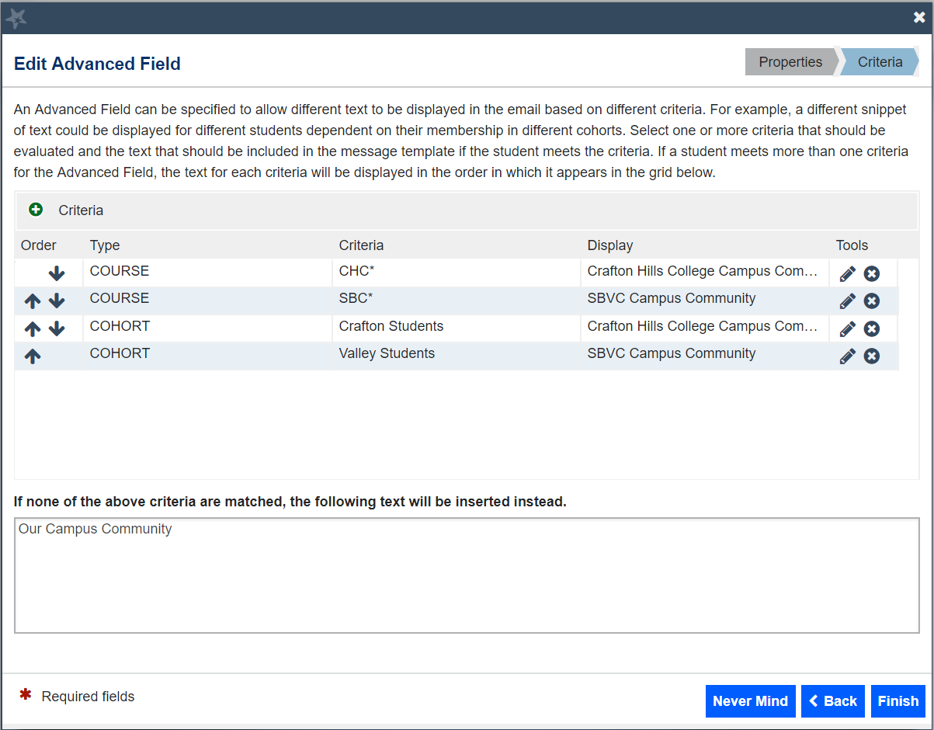

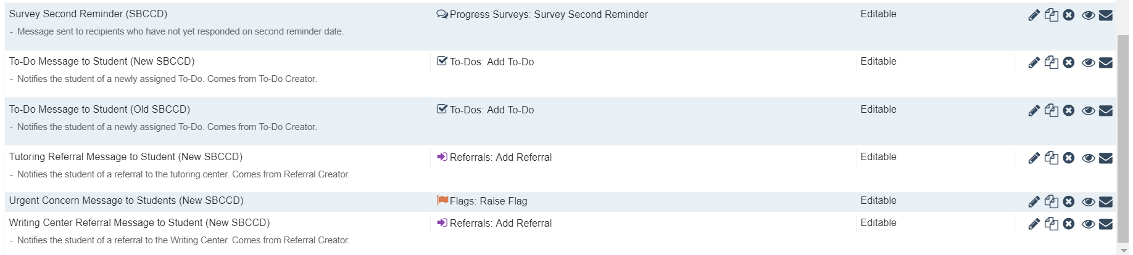
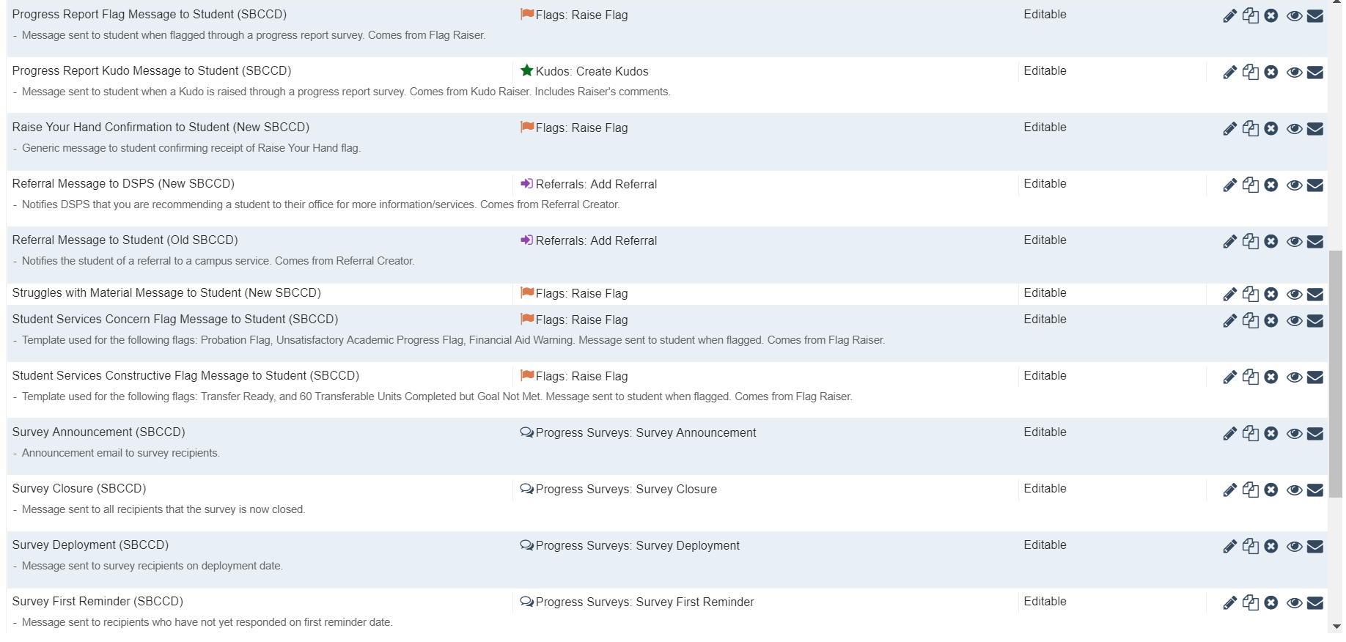
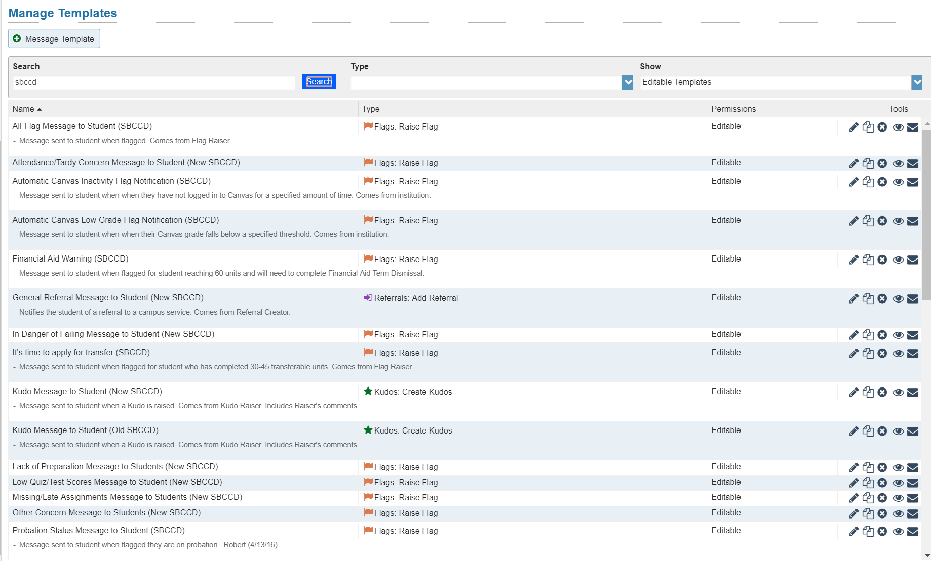
Templates (SBCCD) IMAGE BELOW NEEDS TO BE UPDATED
‌
Tracking Item Messaging Templates
These templates have been copied and pasted in to each individual tracking item’s comment box. The actual “template” contains the subject line and the snippet “Raiser’s Comments” in the body. Text message template reads: “‌Dear [Student First Name],
You have been flagged in Starfish at [Institution Name]. It is important that you login to your Starfish account to review all the details of your flag. You can access Starfish at http://sbccd.starfishsolutions.com/starfish-ops”
This allows the item raiser to preview and edit the message before it is sent out in their name. Separate messaging templates are used for progress surveys.

Tracking Item Name | Message location | Message
Flag:  30+ CSU Transferable Units Completed | Messaging Template | ‌Dear [Student Full Name],  Congratulations! You've completed 30+ CSU transferable units. This is quite a milestone in your transfer journey. If you haven't met with your counselor recently or visited the University Transfer Center, it's time to make an appointment. Typically, students must apply to a Cal State (ex. Cal State San Bernardino) while you are in your last year at Crafton Hills College (October 1 – November 30th). Please accept this Canvas invitation https://sbccd.instructure.com/courses/21998. This is not a class but a set of modules to help you navigate the transfer process, apply on time, and transition from Crafton to the university successfully.  Located in CCR 220 (above the Financial Aid Office). Website: www.craftonhills.edu/transfercenter. Phone: 909-389-3399  During times of school closures, please visit https://www.craftonhills.edu/current-students/university-transfer-center/virtual-services.php
Flag:  30+ UC Transferable Units Completed | Messaging Template | ‌Dear [Student Full Name],  Congratulations! You've completed 30+ UC transferrable units. This is quite a milestone in your transfer journey. If you haven't met with your counselor recently or visited the University Transfer Center, it's time to make an appointment. Typically, students must apply to a UC (ex. UC Riverside) while you are in your last year at Crafton Hills College (October 1 – November 30th). Please accept this Canvas invitation https://sbccd.instructure.com/courses/21998. This is not a class but a set of modules to help you navigate the transfer process, apply on time, and transition from Crafton to the university successfully.  Located in CCR 220 (above the Financial Aid Office). Website: www.craftonhills.edu/transfercenter. Phone: 909-389-3399  During times of school closures, please visit https://www.craftonhills.edu/current-students/university-transfer-center/virtual-services.php
Flag:  Attendance/Tardy Concern | Tracking Item - Flag | Subject: We miss you in [Course]  Class isn't the same without you!  You can be successful in your academic studies and attending class is the first step to accomplishing your goals. Missing class content can affect your grades, academic performance, and possibly have financial consequences. It's not too late for you to change your attendance habits. Let me know if there is anything I can do to help.  Sincerely,
Flag:  Automatic Canvas ___ Day Inactivity Notification | Messaging Template | ‌Dear [Student First Name],  This flag, [Flag Name], has been raised due to your inactivity in Canvas (this includes weekends). To lower this flag, please login to Canvas and complete any required requirements in your course, [Course Name].  [Institution Name] has many resources that can aid your effort to improve academic performance and assist with individual concerns. If you need any assistance, you can contact your instructor, visit the campus Counseling Center, or check out our services in your My Success Network in Starfish.  We care about your success!  Sincerely,  [Institution Name]
Flag:  Automatic Flag for Missing Assignments (in Canvas) | Messaging Template | Dear [Student First Name],  This flag, [Flag Name], has been raised in your [Course Name] course. This flag will automatically lower when submit your missing assignment(s) to your instructor, and your grade is entered into the Canvas gradebook. Keep in mind, each course may have a different policy regarding late work, and your instructor's policy takes precedence.  [Institution Name] has many resources that can aid your effort to improve academic performance and assist with individual concerns. If you need any assistance, you can contact your instructor, visit the campus Counseling Center, or check out our services in your in My Success Network Starfish.  We care about your success!  Sincerely,  [Institution Name]
Flag:  Automatic Low Grade Notification (___% or less) | Messaging Template | ‌Dear [Student First Name],  This flag, [Flag Name], has been raised due to your low grade in [Course Name]. This flag will automatically lower when your grade goes above your instructor's specified threshold.  [Institution Name] has many resources that can aid your effort to improve academic performance and assist with individual concerns. If you need any assistance, you can contact your instructor, visit the campus Counseling Center, or check out our services in your My Success Network in Starfish.  We care about your success!  Sincerely,  [Institution Name]
Flag:  In Danger of Failing | Tracking Item - Flag | Subject: Don’t go off your path! Action Required in [CourseName]  You are not currently earning a passing grade in class, and I'm concerned. It’s common for students to go through challenges like this and overcome them.  Please contact me right away to discuss your options and develop a plan of action. Students who use campus services are more likely to be successful. Check out our campus’s services in your My Success Network in Starfish.  Sincerely,
Flag:  Lack of Preparation | Tracking Item - Flag | Subject: Get ready. Get Set. Let’s Learn in [CourseName]  Students who prepare for class usually engage more in class and achieve better grades. The more you participate both in and out of class, the more you remember.  I have noticed that you are not always ready at the start of each class. Please contact me to discuss how you can be better prepared for class and increase your chances of success.  Sincerely,
Flag:  Low Quiz/Test Scores | Tracking Item - Flag | Subject: Low Test/Quiz Score in [CourseName]  Based on your recent test/quiz scores, your grade is falling, but you can change that. A struggle is just an opportunity for growth, and it’s common for students to go through challenges like this and overcome them.  Here are some academic steps that your peers have taken to be successful:  1. Attend and participate in all class activities  2. Take good notes  3. Study frequently  4. Attend tutoring  If your struggle is not class related, please contact me or, for a list of campus services, visit your My Success Network in Starfish.  Sincerely,
Flag:  Missing/Late Assignments | Tracking Item - Flag | Subject: You have missing or late assignments in [CourseName]  Students who complete assignments on time and interact with course material frequently are more successful in the class.  According to my records, you have not (yet) submitted one or more assignments. Please contact me to talk about your next steps regarding this work.  Sincerely,
Flag:  Other Concern | Tracking Item - Flag  (same as old template) | Subject: I’m concerned about you in [CourseName]  I am concerned about your academic progress in class. I have raised this flag because I care about you and your academic success.  Our campus has many resources that can aid your effort to improve academic performance and assist with individual concerns. Check out our campus’s services in your My Success Network in Starfish or contact me with any questions.  I care about your success!  Sincerely,  p.s. You may also be contacted by a campus representative as a follow up to this flag.
Flag:  Struggles with Material | Tracking Item - Flag | Subject: Stick with it! You can be successful in [CourseName]  Learning takes place over a period of time. For some, it requires more time or effort than others, but it will come. Learning is different for every student and I want to help you identify ways to assist you in the learning process. Please contact me to discuss course relevant techniques to help you grasp the concepts and key skills necessary for success.  Sincerely,
Flag:  Urgent Concern | Tracking Item - Flag | Subject: Urgent Concern in [CourseName]  THIS FLAG HAS NO MESSAGING TEMPLATE DUE TO ITS UNIQUE NATURE. PLEASE ERASE THIS MESSAGE AND COMPOSE YOUR OWN MESSAGE TO THE STUDENT (AND NECESSARY CAMPUS PERSONNEL) REGARDING YOUR URGENT CONCERN. THIS FLAG WILL BE SENT TO OUR FLAG TRIAGE TEAM (AS WELL AS THE STUDENT) AND WILL BE REVIEWED AS SOON AS POSSIBLE.
Flag:  Raise your hand  (confirmation of receipt from student raised flag) | Messaging Template | Subject: Help is on the way!  Dear [StudentFirstName],  Thanks for being proactive in finding assistance. We have received the following request from you.  Category: [ITEMNAME]  Raised On: [DATE]  Your Comments: [RAISECOMMENTS]  You’ll receive a response to your question shortly. We look forward to helping you!  Sincerely,  Student Success Team
Flag:  Raise your hand  for food/housing insecurity | Messaging Template | ‌Dear [Student Full Name],  You're an important member of our Crafton family and on behalf of Crafton Hills College, we wanted to reach out with several resources on campus that you might find useful:  Food Pantry  We all need to eat and it's difficult to do our best academically if we don't have reliable access to food. All CHC students are eligible to receive free "Grab and Go" Meal Kits, single serving items, and more. Click on the link below to find out more about our campus Food Pantry:  https://www.craftonhills.edu/current-students/coach-cupboard.php  Housing Resources  Fixed, regular, and adequate housing is critical to our academic success. Visit the link below to learn about Housing resources available to our students:  https://www.craftonhills.edu/current-students/homeless-student-services.php  Emergency Assistance Funds  This fund exists to provide direct financial assistance to students experiencing unforeseen financial hardships such as access to technology at home, lost jobs/wages, and basic needs (food and rent).  To find out more, click on the link below:  https://laserfiche.craftonhills.edu/Forms/KliL5  Please don't hesitate to reach out to us if you have any questions or if there's anything we can do to support you!  Sincerely,  Caring College Resource Committee  chcstudentsuccess@craftonhills.edu
Progress Report Flags | Messaging Template | ‌Dear [Student First Name],  I am concerned about your academic progress in [Course Name]. I have raised this flag, [Flag Name], because I care about you and your academic success.  [Raise Notes]  [Institution Name] has many resources that can aid your effort to improve academic performance and assist with individual concerns. Please contact me with any questions, or for additional resources or suggestions for improvement. You may also be contacted by a campus representative as a follow up to this flag.  I care about your success!  Sincerely,  [Instructor’s Name]
Progress Report Kudos | Messaging Template | ‌Dear [Student Full Name],  Congratulations! You have been awarded a Kudo titled "[Kudos Name]" in [Course Name].  I appreciate your dedication and hard work in the classroom. Keep up the good work!  [Raise Notes]  Sincerely,  [Instructor’s Name]
General Kudo | Tracking Item - Kudo | Subject: Keep up the good work in [CourseName]  Way to go!  Your classmates and I appreciate your dedication and hard work in the classroom.  Continuing these good academic habits will lead to your success! Keep up the good work, and you'll go the distance!  Sincerely,
All Referrals | Tracking Item - Referral | Subject: I believe you would benefit from a(n) [ReferralName]  Did you know that students who use the campus support services are more likely to pass their courses and complete their academic goal(s)?  Below you will find a referral that I believe will help you. Please follow up with this office as soon as possible to get the assistance you need quickly.  Referral Name:  Course:  Comments:  Due Date:  Sincerely,
Tutoring Referral (CHC vs. SBVC) | Tracking Item - Referral | Crafton Hills College  Subject: I believe you would benefit from a(n) [ReferralName]  Hello,  Your instructor has referred you to CHC Tutoring for (course name).  (INSTRUCTOR: INSERT YOUR COMMENTS AS TO WHAT YOU WANT THE STUDENT TO FOCUS ON AND WORK ON WHILE AT THE TUTORING CENTER. WHEN DO YOU WANT THEM TO VISIT THE TUTORING CENTER BY?)  Tutoring Center services are available remotely, 6 days a week. Please visit our website to follow the instructions and links to make an online appointment or drop-in with a tutor.  https://www.craftonhills.edu/current-students/tutoring-center/online_tutoring.php  Tutoring services help students at all levels succeed. When you make an appointment with us, you will be automatically enrolled in the LRC-900 class. It is non-credit, non-graded, so you will not be charged for this course.  If you have any questions, please call 909-389-3312 or email the faculty coordinator Nick Reichert at nreichert@craftonhills.edu.
Tutoring Referral (CHC vs. SBVC) | Tracking Item - Referral | San Bernardino Valley College  Subject: I believe you would benefit from a(n) [ReferralName]  Did you know that students who use the campus support services are more likely to pass their courses and complete their academic goal(s)?  Below you will find a referral that I believe will help you. Please follow up with this office as soon as possible to get the assistance you need quickly.  Referral Name:  Course:  Comments:  Due Date:  Sincerely,  P.S. Please notify your professor upon completion of your tutoring sessions. This will enable your instructor to clear your referral in Starfish.
Writing Center Referral (SBVC only) | Tracking Item - Referral | Subject: I believe you would benefit from a(n) [ReferralName]  Did you know that students who use the campus support services are more likely to pass their courses and complete their academic goal(s)?  Below you will find a referral that I believe will help you. Please follow up with this office as soon as possible to get the assistance you need quickly.  Referral Name:  Course:  Comments:  Due Date:  Sincerely,  P.S. Please provide your professor with a receipt from the Writing Center upon completion of your appointment. This will enable your professor to clear your referral in Starfish.
DSPS Referral  (not visible to students) | Tracking Item - Referral | Dear DSPS staff,  I am concerned about this student and think s/he may benefit from services offered through DSPS.  I have noticed….  I understand you cannot confirm with me if this student is already part of the program, but I am hopeful you can offer support and resources to him/her.  Thank you.
All To-Dos | Tracking Item – To Do | Subject: To-Do for [Course Name]: [To-DoName]  To help you be more successful, I have added a new To-Do to your student folder.  Below you will find the details of this task. If you have additional questions, please let me know.  To-Do:  Course:  Comments:  Due Date:  Sincerely,
Messaging Templates for Progress Surveys and Automatic Flags
When you send a flag or kudo in a progress survey, the student will receive the following email.

PROGRESS REPORT FLAGS and KUDOS
‌Dear [Student First Name],
You have been provided with feedback through a Progress Report submitted for your course, [Course Name]. Please login to Starfish at
http://sbccd.starfishsolutions.com/starfish-ops for more information.
Sincerely,
Student Success Team at [Institution Name]

After you have set up automatic flags with your Starfish Support person, messages will be sent to students when they do not log into Canvas for your specified amount of days, or when their grade falls below your specified threshold. Below you will see templates of these emails.

AUTOMATIC CANVAS INACTIVITY FLAG
‌Dear [Student First Name],
This flag, [Flag Name], has been raised due to your inactivity in Canvas (this includes weekends). To lower this flag, please login to Canvas and complete any required requirements in your course, [Course Name].
[Institution Name] has many resources that can aid your effort to improve academic performance and assist with individual concerns. If you need any assistance, you can contact your instructor, visit the campus Counseling Center, or check out our services in your My Success Network in Starfish.
We care about your success!
Sincerely,
[Institution Name]
Starfish login: http://sbccd.starfishsolutions.com/starfish-ops

AUTOMATIC CANVAS LOW GRADE FLAG
‌Dear [Student First Name],
This flag, [Flag Name], has been raised due to your low grade in [Course Name]. This flag will automatically lower when your grade goes above your instructor's specified threshold.
[Institution Name] has many resources that can aid your effort to improve academic performance and assist with individual concerns. If you need any assistance, you can contact your instructor, visit the campus Counseling Center, or check out our services in your My Success Network in Starfish.
We care about your success!
Sincerely,
[Institution Name]
Starfish login: http://sbccd.starfishsolutions.com/starfish-ops

If students opt-in to text messaging notifications, the text message will resemble the following:
FLAGS:
“‌Dear [Student First Name],
A flag has been raised in one of your classes at [Institution Name]. Please login to Starfish at http://sbccd.starfishsolutions.com/starfish-ops for more information.”
AUTOMATIC FLAGS:
‌ “Dear [Student First Name],
An automatic flag has been raised in one of your classes at [Institution Name]. Please login to Starfish at http://sbccd.starfishsolutions.com/starfish-ops for more information.”
KUDOS:
“‌Dear [Student Full Name],
Congratulations! You have been awarded a Kudo in one of your classes at [Institution Name]. Login to your Starfish account at http://sbccd.starfishsolutions.com/starfish-ops for more details.”
REFERRALS:
“‌Dear [Student First Name],
You have a Starfish referral from [Institution Name] waiting for you in Starfish. Login to your Starfish account at http://sbccd.starfishsolutions.com/starfish-ops for more details.”
TO-DOs:
“‌Dear [Student First Name],
You have a Starfish "To-Do" from [Institution Name] waiting for you in Starfish. Login to your Starfish account at http://sbccd.starfishsolutions.com/starfish-ops for more details.”

REPORTS

Activity
Gauge usage and adoption of Starfish, focusing on appointments and related activities.

Assignment Analysis
The Assignment Analysis report gives institutions insight into assignments per section, course and department. Specifically, how many assignments are there in each course and how quickly are they being graded. In order to use this report effectively, the department, course and section for all of your course sections must be parseable from the course ID (e.g., in a course ID of BIOL125.01.Fall2012, the department would be BIOL, the course 125, the section 01 and the term Fall2012).

Degree Planner
See how many degree plans have been created, whether they've been approved, and other information about them.

Early Alert Summary
Please select a term to prepopulate date fields or enter dates directly.

Instructor Inactivity
Assess whether instructors are logging in to the course management system.

Intervention Analysis
Analyze activity in Starfish and course outcomes by section.

Low Grades
Analyze which instructors and course utilize the online Gradebook and report on low grades.

Meetings
Gauge usage of types of appointments scheduled vs. those held and actual meeting durations.

Notes
Review comments that appear in students' Starfish folders.

Relationships
Review relationships that exist for any given role.

Required Appointment
This report is intended to help identify students who are required to meet with someone and have not yet done so. For example, many schools require that students meet with an Advisor during the first few weeks of a particular term. This report can help identify those students who have not yet scheduled an appointment. Generally, this report is meant for Advisors and the data returned for Instructors will not be relevant unless students are required to meet with each Instructor individually.

Services
Track appointments, attendance, services hours and who students are meeting with, per service (e.g., Tutoring Center).

Starfish Configuration
Review details of your tracking item configurations including details on role permissions per item.

Student Intake
Review new and updated Student Intake data for selected cohorts and organizations.

Success Plan
Report on status of assigned Success Plans and review to dos/referrals raised via Success Plans.

Surveys
Assess instructor participation in progress surveys.

Tracking Items (Flags, Kudos, Referrals, and To-Dos)
Discover which flags are being raised and cleared. Filter and sort on flag types, students, or flag raisers.

Semesterly/Annual System Updates Check List

Campus Specific Starfish Support
- Provide Evaluators with Tracking Items Report to view outstanding and open “to-do” items at the end of each semester. Provide Dean of Student Services a list of open Referrals so they can follow up with the appropriate departments.
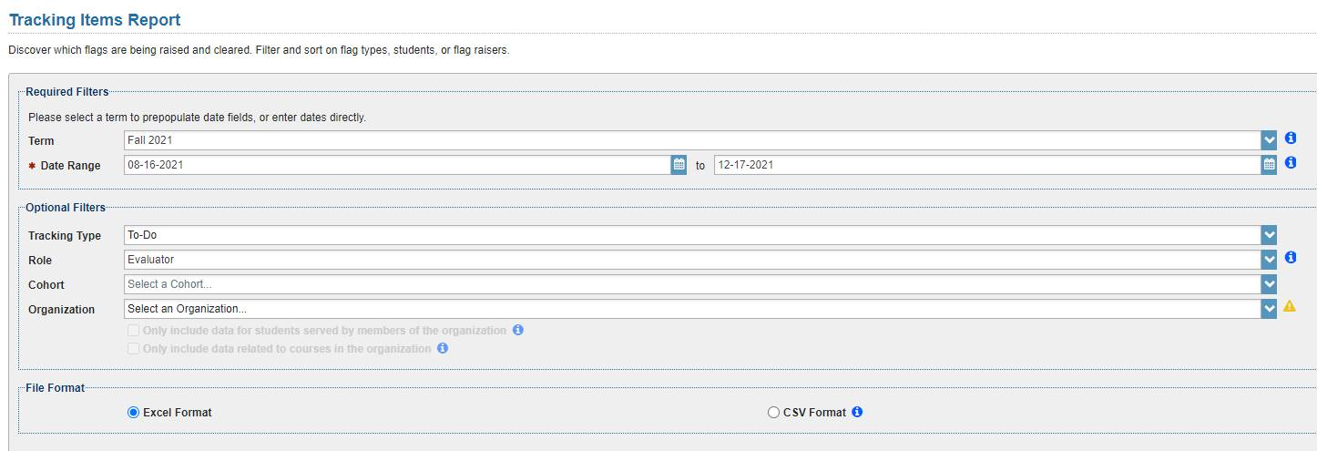

- Update Services Tab in Starfish at the start of each academic year, unless changes occur mid-year.
  - SBVC: Yancie and Yecica
  - CHC: Kristina
- Update Cohorts based on Enrollment. Valley Bound, Valley Dreamers and Guardian Scholars, and Valley FYE are based on course enrollment (Sharaf Williams). Terms listed at the end of each course identifier needs to be updated to match current term.
  - SBVC: Yancie and Yecica
  - CHC: does not currently apply
- Update any tracking items that are targeted to course sections, cohorts, or terms. Use the Starfish Configuration Report (Cohort Restricted? and Course Restricted? columns) to quickly highlight items that may need to be updated.
- Set up automatic flags, low grades and inactivity, based on faculty demand
(faculty opt in each semester and hand enter each section into system)
  - SBVC: Michelle/Yecica
  - CHC: Breanna
- Create new Progress Surveys, by copying surveys from the previous term, updating the course sections targets and making other desired changes. Save the updated copy.
(5-, 5-, 5-, 8-, 8-, 13/15/17- weeks)
  - SBVC: Michelle/Yecica and Yancie
  - CHC: Breanna
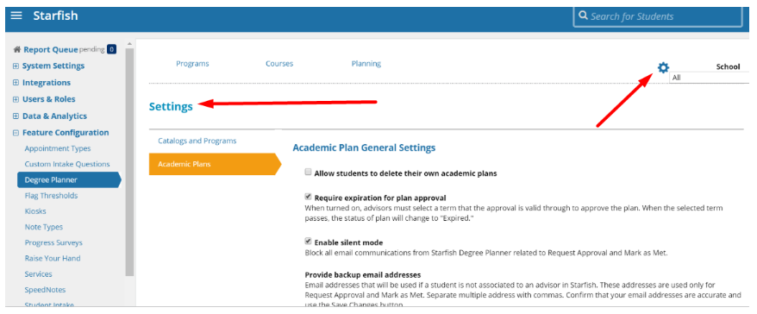
- Degree Planner: Catalog
Configurations which you control that impact both colleges live in the Settings section of Degree Planner Admin (see image below). An example of one that will need to be reviewed when Valley goes live is the Create New Plan Description, as the language there currently only references Crafton.

Additionally, here are some configurations I manage for you on the Hobsons' side that would impact both colleges:
- Allowing students to access the DP tab from Starfish
- Turning on/off Why Did These Courses Build Here?
- Turning on/off the display of the program-wide GPA
- The catalog year display format
- Turning on/off the Mark as Met functionality
- Adjusting the number of years to predict offerings in the future (currently set to 6 years)
- Mapping of which grades are considered passing and which are considered failing/non-passing
  - SBVC: Yancie Carter and team
  - CHC: Kristina

Starfish Work Group (SBVC: Yancie Carter, Yecica Bernardo, Julie Ulloa, Michelle Tinoco, April Dale-Carter, and Marco Cota. CHC: Breanna Andrews, Kristina Heilgeist, Ernesto Rivera, Kristin Garcia, Larry Aycock, and Kirsten Colvey, TESS: Andy Chang)
- Run and review the Tracking Item report to view usage as well as find outstanding items that need to be cleared.
- Bulk clear most Flags, To-Dos, and Referrals at the end of each semester (Jan. 1st, June 1st, and after summer school)
  - Do NOT clear Kudos
  - DO NOT clear Referrals. Instead check with the specific Student Services offices that have outstanding referrals and ask them to clear the ones that are no longer applicable.
  - DO NOT clear the following Flags: “I need help paying for college,” “I have a question but don’t know where to start,” and any with the words “3-flags” in the title. If accidently cleared, a copy of the flag will need to be made.
  - DO NOT clear the following to-do’s: SEP and degree plan items, a to-do indicated by a “unit” count range, “Transfer Ready.”
- Create or modify roles as needed. Complete “New Starfish Role Request” and submit to TESS via Help Ticket (may require user app if the person is being added to a currently existing role).
- Create or modify cohorts. Complete “New Starfish Cohort Request” and submit to TESS via Help Ticket
- Create or modify attributes. Complete “New Starfish Attribute Request” and submit to TESS via Help Ticket
- Create or modify wording in tracking items
- Create or modify messaging templates
- Modify Degree Planner Settings

DCS Tech Team
- Add/update Roles, Cohorts, Attributes as requested by the District Starfish Work Group
- Add new terms in Starfish Admin > System Settings > Terms (or automate using the academic calendar file via the Starfish Universal Adapter). Make sure Academic Calendar File is being updated, then this information will transfer to Starfish.
  - This also needs to be done for specific attributes such as “Tutoring Notification”
- Verify old and new term Display Start and End Dates to avoid gaps in relationships. This should be part of the DCS "Registration Check List" and be assigned to the Degree Planner administrator at each campus (alternated each term).
- If you restrict courses coming to Starfish from your LMS (e.g., Canvas), notify Starfish Support at starfishsupport@hobsons.com of new terms/course patterns you have added to the LMS Adapter (e.g., Canvas Building Block).
- Ensure that term-based SIS files are tested and being sent for the new term. Files may include relationships, organizations, cohorts, sections, and enrollments, but vary per institution.
  - Student population (current 4 terms pulled daily) will be updated to include the new term; but another term will need to be dropped off. For example, at the beginning of Summer 2018, replace the current group of Spring 2017, Summer 2017, Fall 2017, and Spring 2018 with a new group of Summer 2017, Fall 2017, Spring 2018, and Summer 2018
  - All cohorts except the Probation will need to be updated for the current term, at the beginning of each term. For example, at the beginning of Summer 2018, change the term associated with the cohorts from Spring 2018 to Summer 2018
  - The Probation cohort will be updated to pull the previous term from the new term. For example, at the beginning of Summer 2018, the previous term will now be Spring 2018; at the beginning of Fall 2018, the previous term will still be Spring 2018; at the beginning of Spring 2019, the previous term will now be Fall 2018.

Updating XEPIOG each term for Probation Students

XEPIOG is part of the Starfish coding package from Ferrilli. This form is the setup for Organizations, Cohorts, or Relationships. Processing for the Probation Students contains a Uniquery select statement that needs to be update per term.

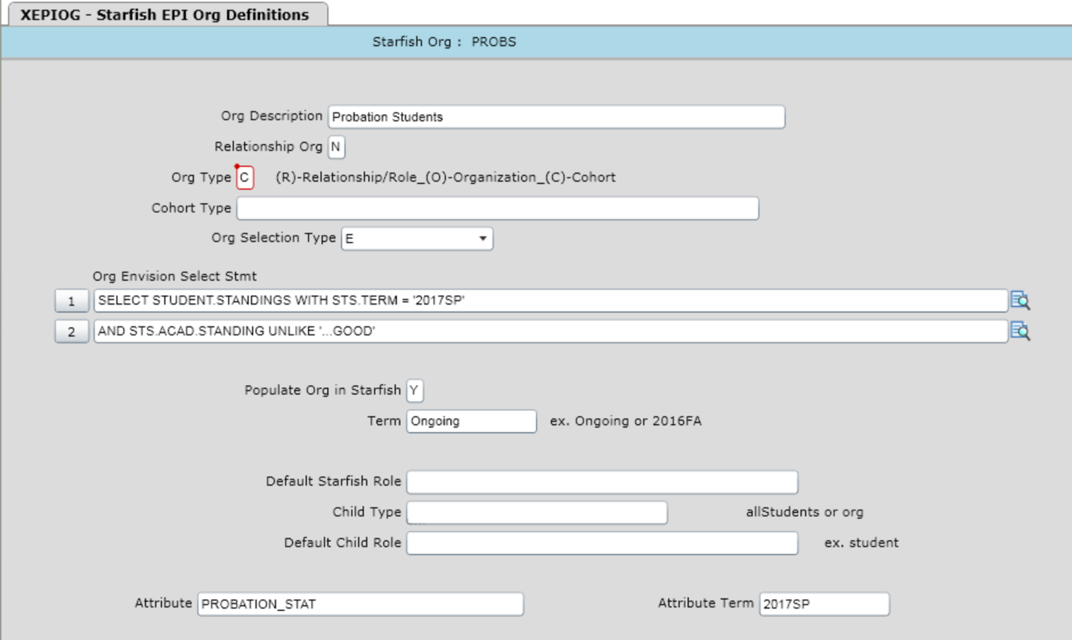

Update the select statement each term to the latest term. For probation student processing the term will be one term behind (except for fall, data needs to be pulled from the previous spring).

Notice that there is also Attribute processing at the bottom of the screen. This will also create an attribute that is term based. The attribute term must be updated to match the term in the select statement.

Note for TESS – There are other cohort/organizations that contain a term in the select statement or attribute term field. These will also need to be updated each term.

PRODUCT ENHANCEMENT REQUESTS

Enhancement requests are to be submitted through Compass. Then use listservs and groups to publicize your request and ask for others to vote for it.

- Starfish app for mobile accessibility.
- Multiple “check box” style options for raising simultaneous flags and/or referrals would be helpful (i.e. “In Danger of Failing” flag and a referral to the tutoring center… or simply two different flags). One message would be sent to students with all their notifications on it. This would also allow the follow-up team would have all the info for that student in one place, without have to go through multiple individual flags/referrals.
- For Canvas integration, have the attendance feature log when students log in/log out.
- Language Toggle button: makes content accessible in other languages.
- Reminder feature for faculty inactivity. Faculty can set time intervals to receive reminder emails telling them to go into Starfish and input tracking items.
- The ability to run reports on faculty activity in Starfish so we know which faculty are comfortable using the system, and which ones we should reach out to directly.
- Change the color of a dropped student’s name on the roster or add an icon so we can identify them from our currently enrolled/active students.
- In progress survey reports, we would love to see a column for students’ courses they are enrolled in, so we can sort by student, see all their classes and know which of their instructors hasn’t filled out the survey yet. I am aware that there is a page in the Progress Survey Report about instructor completion, but it doesn’t tell us which students are in their class and therefore don’t know which students are not being provided with feedback.
- The current “Instructor Inactivity” report pulls data on instructor LMS activity. However, it would be really helpful to have another report that allows us to see which instructors are (or are not) using Starfish so we can target them to provide necessary training and support to start using Starfish.
- Allow students to see Survey results submitted for them. (Submitted).
- Option to save line items on surveys.
- In the Students Tracking Tab, we would like to be able to filter based on how the item was raised (manual, system, or survey).
- Allow faculty the option to see and edit messaging templates before they are sent. This would apply for raising flags, kudos, referrals, and To-Dos.
- Add a field to allow a student’s preferred name to be imported into Starfish.
- Add a checkbox option on the form for filling out flags that provides faculty with the option of selecting: “Please address immediately” or “FYI Flag” (the second option will still be used for a 3-flags rule flag).This feature should also be included in the options for filtering as well.
- We would like to request that someone can have the permission to assign an automatic flag to others if the “assign” permission on that flag is checked. Currently you also need to have the “manage” permission checked, which would also allow them to clear the flag (which is a “no, no” for automatic flags).
- Add a column for students’ grades on the progress report form (and possibly # of absences as well), so instructors do not have to click on each student individually to be reminded of their current standing in the course.
- We would like a report built for “Student information” which would include the ability to download students’ GPA, grade summary, demographics, majors, etc.
- When surveys are built, there are already options for them to go to specific cohorts, organizations, or courses, but we would love to also have an option for course length. This way we could easily build surveys to go out to each course during its halfway point, whether that be a 9-week course or 14- or 16- week course, etc.
- It would be nice to have tracking items color coded in the tracking screen. For example: If a flag has come in but nothing has been done with it yet, then it is a transparent red color. Once a note is added, then it turns a transparent yellow color. When the flag is resolved, it turns a transparent green color.
- In the tracking tab, add a column that states the cohorts the student is part of. This will enable specific departments to easily identify which students are within their program and address those tracking items.
- Currently there is a SAVE button at the bottom of tracking item screens when you are raising one... however the wording is very confusing since SAVE actually means SUBMIT within Starfish. I have been told by many that they think it will save to a draft if they hit SAVE and are upset when it actually gets sent out.
There are other screens in the system that do say SUBMIT but the wording is not consistent. Please consider changing SAVE to SUBMIT where applicable.
- My campus is discussing adding cohorts for each of our majors to allow students to be filtered on the faculty roster by major... however I also know there is a cap for the amount of cohorts you can have... and we would surpass this limit. When playing around in the Role permissions, we already allow instructors to view "Programs" (majors), but this is only visible when you click on an individual student's file. We would love to have a way to filter an entire roster or student list based on students’ majors.
- With the Canvas Integration, flag thresholds can be set to raise a flag when a student's grade drops below a specified percent… We would like to see Kudos be set up similarly, and sent out when a student's grade goes above a specified threshold.
- Currently, only admins can run course forecasting reports, however Department Chairs (among others) would benefit greatly from having direct access to this information. We would love to see other roles be allowed to have "report running" access.
- Currently, you can only check tracking items in a progress survey, but we would find it useful to be able to type in a student's grade in the course as well.
- Send students a confirmation email upon the completion/submission of a progress survey. This would be used instead of sending emails for individual tracking items (currently they may get 4 emails per progress survey). Please vote for this if you feel it will better students' user experience and cut down on email overload.
- When setting up Automatic Low Grade Flags and LMS Inactivity Flags, allow each section inputted to have individual “turn on”/”turn off” dates as part of the set up process. This will erase the need to manually go in on specific days to turn section specific flags on/off.
- We would love to see the ability to clear referrals based on a student swiping in or out of a kiosk. For example, if a faculty member raised a referral for a student to visit the tutoring center, the referral close once the student has swiped in and/or out of the tutoring center. To take this one step further, when swiping in, it would be great for the student to be able to see the referral and verify that is the reason they are visiting the tutoring center (and reminding them what they should be focused on).
- Currently (with the new Progress survey redesign), the submit button is visible on the screen at all times, rather than only at the bottom. This is causing many of our faculty to click "submit" after the first student's info is entered, and despite the new warning message, they submit the entire survey. I would like to suggest that the "submit" bottom remain at the bottom of the page, only becoming visible once they scroll all the way down.
- We would love to see the ability to run a report for future course forecasting, allowing department chairs to better schedule courses... which courses to offer, how many sections, when to offer them, etc. based on students' degree plans (and possibly availability).
- Our faculty would like to be able to add attachments to referrals. For example, if a student is being referred to tutoring, they would like to attach a document of an assignment they should work on.

And the list goes on. Due to the number of people working in the system and submitting enhancement requests, they could not possibly all be documented here. These were the ones submitted in the early stages of our Starfish development and implementation.

Appendix

New Starfish Role Request
Name of Requestor:
Date:

Directions: Please write the name of the new role at the top and check all boxes you feel should be
made available to the students as well as to the person(s) in that role. Upon completion, submit this for to TESS via Help Ticket.

- Name of role:
- Privilege Set (check one)

  - Instructor
  - Student
  - TA
  - AcademicProvider
  - AcademicLeader
  - XfunctionalProvider
  - XfunctionalLeader
  - ServiceProvider

- Visibility to students (keep in mind, only information entered into the person’s profile will be displayed):
- Show in Student Folder (Will be shown to other users. Confidential relationships should not check this box)
- Show in Student Success Network (student will see this person in their success network)
- Show Primary Phone Number to Student
- Show Cell Phone Number to Student
- Show Video Phone Number to Student

- Visible Student Data (to the person who is in this role):
- Academic Plans
- Admissions (high school GPA, first term date, ACT/SAT/TOEFL/placement scores)
- All Courses
- All Grades
- Courses for Course Context
- Demographics (date of birth, Pell Grant Eligible, First Gen Student status, Gender, Race, Residence)
- Email Addresses
- Grades for Course Context
- Phone Numbers
- Programs (major)
- Score Details
- Student Attributes (financial aid info, academic probation status, current GPA, etc.)
- Student Files
- Student ID
- Student Success Score
- Term Status (broken down by semester, FT vs PT, course load and unit count, academic standing, GPA)

Other Notes:

New Starfish Cohort Request
Name of Requestor:
Date:

Directions: Please write the name of the new cohort at the top, check the type of cohort, and include a brief description. Upon completion, submit this for to TESS via Help Ticket.

- Name of Cohort:
- Cohort Type (check one)
  - Crafton Hills College
  - DSPS
  - Foster Youth/Guardian Scholars
  - On Probation
  - San Bernardino Valley College
  - Other: __________________________
- Provide a description of the cohort and its intended use:

------------------------------------------------------------------------------------------------------------------------------------------

New Starfish Attribute Request
Name of Requestor:
Date:
Directions: Configure the attribute type below. For each attribute, a name and key must be specified
as well as the data type. The key is the attribute identifier that will be sent in the user_attributes.txt
file for each student, along with their value for the attribute. In the Display Format field, specify how
the attribute should be displayed in the system on the Student Folder. Upon completion, submit this
for to TESS via Help Ticket.

- Name of Attribute:
- Possible abbreviation of attribute:
- Allow users to search by this attribute (circle one) Y or N
- Show in student Folder Overview (circle one) Y or N
- Attribute Type (check one)
  - String
  - Numeric
  - Boolean
  - Date / Time
  - Enumeration
- Display Format (The display format currently supports the identifiers ${CREATED_DATE} and ${UPDATED_DATE} and ${VALUE} in the string. These identifiers will be substituted by literal values before being displayed in the Student Folder.)

In-Class Reminder of Starfish Tracking Items

Kudo | Students’ Names
Extracurricular Activity
Keep Up the Good Work
Kudos to You
Outstanding Academic Performance
Positive Attitude and Effort
Positive Peer Support
Prepared and Ready for Class Sessions
Showing Improvement

Flag | Students’ Names
Attendance/Tardy Concern
In Danger of Failing
Lack of Preparation
Low Test/Quiz Score
Missing/Late Assignments
Other Concern
Struggles with Material
Urgent Concern
Referral | Students’ Names
Admissions and Records
CalWORKs
Career Center
CARE
Counseling
DSP&S
EOPS
Financial Aid
Health and Wellness Center
Honors Program
Library and Research
REACH (homelessness)
Student Life
Student Success
Testing Center
Transfer Center
Tutoring
Veteran’s Resource Center
To-Do | Students’ Names
General Reminder
Make an Appointment with your Instructor
Make an Appointment with your Student Success Advisor
Purchase Required Materials for Course
Set up your Starfish Profile and Complete Intake Survey

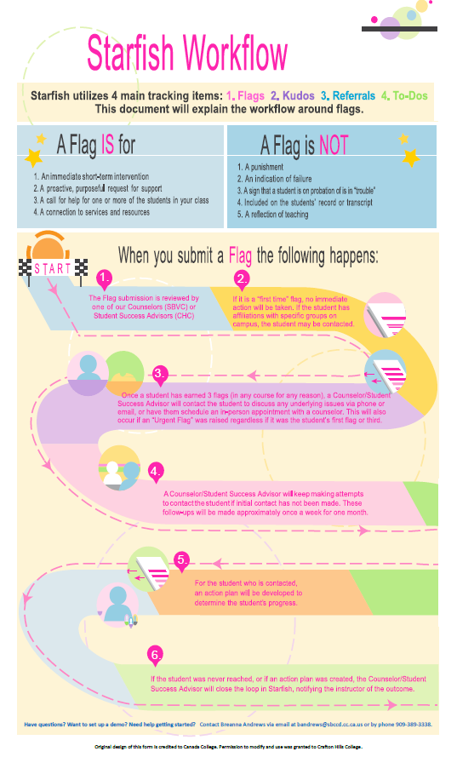
Starfish Workflow

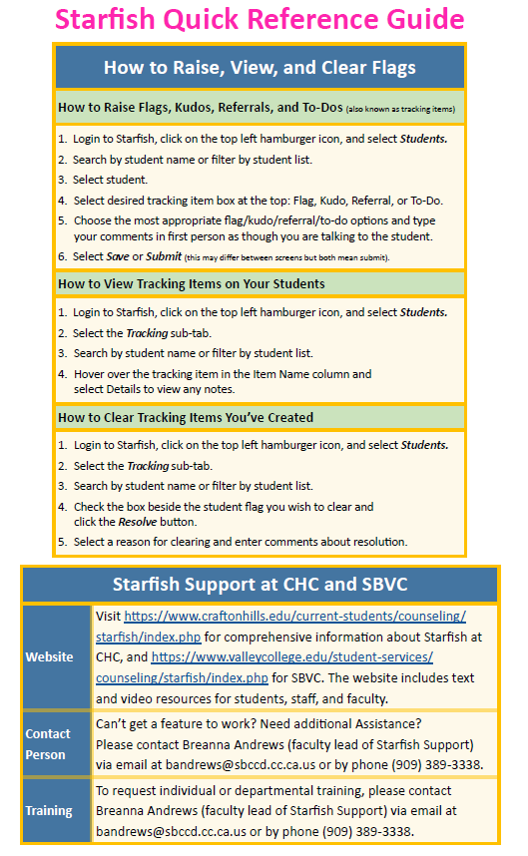
Quick Reference Guide for Tracking Items
Workflow

Flag Triage Action Guide for Gen. Pop. Students:
What to do when an Academic Flag is Raised.
Name of Flag | What To Do
3-Flags * | Do NOT ever clear this flag. Only address and clear the underlying flags that made this appear.
Attendance/Tardy Concern | Depends on severity. Can ignore so “3-Flags” will indicate a pattern.
Automatic Grade Notification * | Do NOT ever clear this flag. Address and contact student, but do not clear it. The system will automatically clear the flag when the students’ grade raises above the threshold.
Automatic Canvas Inactivity Notification * | Do NOT ever clear this flag. Can ignore so “3-Flags” will indicate a pattern, but do not clear it. The system will automatically clear the flag when the student logs into to Canvas.
In Danger of Failing | Address and contact student immediately.
I need help, but don’t know where to start | Assign and address based on need and follow up with student.
I need help in a course | An email is sent to the instructor, so they will already be notified. No action is needed on your part.
I need help paying for college | An email is sent to financial aid. No action is needed on your part.
Lack of Preparation | If raised at the beginning of the semester, contact student to see if they need supplies or inform them of book loan programs and other services for low income (if money is the issue).
Low Quiz/Test Scores | Can ignore so “3-Flags” will indicate a pattern.
Missing/Late Assignments | Can ignore so “3-Flags” will indicate a pattern.
Other Concern | Depends on the topic.
Struggles with Material | Address and contact student. Refer to tutoring if applicable.
Urgent Concern | Assign and address based on need and follow up with student.
REFERRALS | If you notice a referral has gone unaddressed for a while, you may want to contact that department to make sure they are aware of it.

* DO NOT CLEAR THESE FLAGS IN STARFISH

